

Development of an Integrated Subscriber Billing System with an AI-Powered Digital Assistant for Enhanced Client Efficiency: A Solution for D&D I.T Network and Data Solutions

Project Documentation Submitted to the Faculty of the

School of Computing and Information Technologies

Asia Pacific College

In Partial Fulfillment of the Requirements for

Introduction to Systems and Design for CS/IT

M/S NTSDEV

By

| *Albania, Roman Nikko* | *Elfa, Nekeisha Ashlyn E.* |
| --- | --- |
| *Ditano, Abdul Hasheem O.* | *Monforte, Edgar Louise P.* |

2024

**Table of Contents**

Executive Summary i

List of Figures ii

List of Tables iii

I. Introduction 1

1.1 Project Context 1

1.2 Statement of the Problem 1

1.3 Objectives 1

1.4 Significance of the Project 2

1.5 Scope and Limitations 2

II. Review of Related Literature / Systems 3

III. Current Systems 4

3.1 Current System 4

3.2 Technical Background 4

3.3 List of Processes 4

3.4 Gap Analysis 5

IV. Proposed Solution 5

4.2 Lean Canvas 5

4.3 Product Vision 6

4.4 Technology Specifications 7

4.5 Feasibility 8

V. Requirements Analysis 10

5.1 Product Backlog / User Stories 10

(Product Backlog 10

5.2 Use Case Diagram 11

5.3 Data Flow Diagram …………………………………………………………………... 11

5.4 Fully Dressed Use Case ………………………………………………………………. 11

5.5 Test Cases ……………………………………………………………………………. 11

5.6 Activity Diagram with Swimlanes ……………………………………………………. 11

5.7 Entity Relationship Diagram …………………………………………………………. 11

5.8 User Classes and Characteristics 11

5.9 Prototype 12

5.10 Release Plan 12

References 13

Appendices 14

Appendix A: Project Vision 14

Appendix B: Schedule/Release Plan 15

Appendix C: Product Roadmap 16

Appendix D: Users’ Manual 17

Appendix E: Teams Meetings 18

# Executive Summary

This project aims to enhance operational efficiency and customer satisfaction for D&D I.T Network and Data Solution by developing a two-pronged solution: a subscriber billing system and an internal AI digital assistant. These solutions are designed to automate billing processes, reduce errors, and improve service delivery. The project is scheduled to be completed within one year and the primary objectives are to implement an automated subscriber billing system to replace manual processes and deploy an internal AI digital assistant to streamline administrative tasks and data management. The primary stakeholders are the community of D&D I.T Network as well as the company’s 500+ subscribers. The project methods include developing a user-friendly platform that automates billing processes, integrates payment gateways, and offers online access to billing information, and implementing an AI-driven tool to automate tasks like identifying overdue accounts, generating analytical reports, and managing customer records. The expected outcomes include a significant reduction in billing errors, faster invoice processing and delivery times, and enhanced customer satisfaction by decreasing complaints related to payment issues. Customers will benefit from improved transparency and self-service capabilities, while clients will gain efficiency, allowing them to focus on strategic tasks. This initiative will strengthen D&D I.T’s reputation as a reliable ISP, enhancing customer loyalty and market competitiveness. Next steps involve finalizing the project plan, securing necessary resources, developing and testing the subscriber billing system and AI digital assistant, deploying the systems, and monitoring performance with necessary adjustments. By implementing these solutions, D&D I.T aims to improve operational efficiency, reduce billing-related errors, and enhance overall customer satisfaction, positioning itself as a leading ISP in the Philippines.

# List of Figures

Figure 1 Fishbone Diagram ……………………………………..…………………………………… 18

Figure 2 Lean Canvas ...……………………………………………………………………………... 19

Figure 3 Use Case Diagram …………………....……………………………………………………..29

Data Flow Diagram

Figure 4 Level 0 ……………………………………………………………………………………….. 30

Figure 5 Level 1 ……………………...………………………………………………………………... 31

Figure 6 Level 2 Process 2.1 ……………………...…………………………………………………. 32

Figure 7 Level 2 Process 2.2 ……………………...…………………………………………………. 33

Figure 8 Level 2 Process 2.3 ……………………...…………………………………………………. 34

Figure 9 Level 2 Process 2.4 ……………………..………………………………………………….. 35

Figure 10 Level 2 Process 2.5 ……………………….………………………………………………. 36

Activity Diagram with Swimlanes

Figure 11 Select Plan …………………………………………………………………………………. 63

Figure 12 View Billing statements .…………………………………………………………………... 64

Figure 13 Pay the Bill …………………………………...……………………………………………. 65

Figure 14 Change Plan ……………………………………………………………………………….. 66

Figure 15 Set Status (Active/Inactive) ...…………………………………………………………….. 67

Figure 16 Ask AI for Subscribe’s Data ...………………………………………………………..….. 68

Figure 17 Generate Billing Report ...………………………………………………………………... 69

Figure 18 Entity Relationship Diagram ……………………………………………………………… 70

Prototype

Figure 19 Homepage ...……..………………………………………………………………….……... 73

Figure 20 Account Statement Page ………………………………..….…………………………… 74

Figure 21 Payment Page ……………………………..…………………………….………………... 75

Figure 22 AI Digital Assistant Page ..…………………………………………………………………76

Figure 23 AI Digital Assistant Page .…………………..………………………………….………..…77

Figure 24 Schedule/Release Plan …….………………..……………………….……..………….…83

# List of Tables

Table I List of Processes ……………………………………………………………………………… 14

Table II Product Vision ………………………………………………………………………………... 21

Table III Backlog Table ………………………………………………………………………………... 27  
  
Table IV Fully Dressed Use Case …………………………………………………………………… 37  
  
Table V Test Cases ……………………………………………………………………………………. 44  
  
Table VI Activity Diagram with Swimlanes ………………………………………………………….. 63

Table VII User Classes and Characteristics ………………………………………………………... 71

Table VIII Roadmap ..………………………………………………………………………………….. 84

# Introduction

Efficient billing systems are crucial for internet service providers (ISPs) to stay competitive in today's digital age [1]. The absence of a billing system leads to the use of manual methods, such as pen and paper, for billing processes, resulting in errors, delays, customer confusion, and significant time consumption [2]. This is particularly relevant for D&D I.T Network and Data Solution, an Internet Service Provider that offers various internet packages. However, D&D I.T Network and Data Solution faces several challenges.

**Project Context**

D&D I.T Network and Data Solution, an Internet Service Provider in the Philippines, was established within the past two years and offers various internet packages. The company has over 500 subscribers, comprising a mix of small business owners and individuals, and is dedicated to providing affordable, reliable, and high-speed internet services in Mandaluyong, Quezon City, and Taguig. The company's extensive wide-area network infrastructure serves schools, residential areas, corporations, and both the public and private sectors, supporting vast data transmissions involving voice, data, and video applications.

**D&D I.T Network and Data Solutions Mission**

To provide a reliable fiber internet connection nationwide, D&D I.T Network and Data Solution aims to offer service and top-class support that meets and even exceeds customer expectations. Additionally, the company is dedicated to providing useful and suitable value-added services in addition to internet services [3].

**D&D I.T Network and Data Solutions Vision**

A company recognized as the leading Internet Service Provider in the Philippines, delivering high-speed internet nationwide and addressing both corporate and residential market demands [3].

D&D I.T Network and Data Solution, a rapidly expanding ISP in the Philippines, currently utilizes manual billing processes. This has led to a notable rise in billing inaccuracies, such as a 20% error rate in the last quarter, and delays in invoice delivery, causing frustration and dissatisfaction among customers. For instance, there has been a 30% increase in customer complaints related to billing issues. Additionally, managing customer records and identifying overdue accounts is a time-consuming manual process.

To address these challenges, this project proposes a two-pronged solution:

**Subscriber Billing System:** This user-friendly platform will automate the billing process, eliminating errors and streamlining invoice delivery. Customers will be able to conveniently review their statements, explore available plans, and process payments online, improving transparency and self-service capabilities.

**Internal AI Digital Assistant:** This AI assistant will directly access data from the billing system to automate tasks such as identifying account status and information, as well as generating reports for data analysis. This will free up D&D I.T's staff to focus on other critical tasks and improve overall operational efficiency.

By collaborating with D&D I.T Network and Data Solution, the developer aims to achieve operational efficiency. The project directly supports D&D I.T's mission by enhancing the reliability and efficiency of their services, thereby exceeding customer expectations and providing valuable additional services. It aligns with the company's vision by contributing to their recognition as the leading ISP in the Philippines, known for delivering high-speed internet and addressing diverse market demands [3].

## Statement of the Problem

This project addresses three significant challenges faced by the company. First, the lack of an automated billing system necessitates reliance on manual methods, leading to increased errors and delays. Second, there is difficulty in efficiently tracking billing reports, leading to confusion in managing subscribers’ records and further complicating the billing process.

Addressing these issues is essential for improving operational efficiency and optimizing processes within the organization.

The project aims to address the following problems of the company:

**Lack of an automated billing system**

Consequently, they have been using manual methods including the use of pen and paper to record data, manage information, and generate billing reports. This approach significantly increases the risk of errors and delays, given the time-sensitive nature of billing tasks.

**Challenges in monitoring reports**

The company currently relies on manual methods for monitoring billing reports like writing billing reports using the old way which is by the use of pen and paper. This paper-based system is prone to errors and inconsistencies, creating confusion for both internal staff and customers. Resolving billing inquiries becomes a slow process, potentially leading to customer dissatisfaction.

**Payment process through 7-11 stores**

The company has been facing challenges with its payment process. The customers have to go to 7-11 stores, which can be inconvenient due to environmental factors such as rain and rising temperatures. Additionally, long lines and occasional maintenance issues with store servers have contributed to errors and delays, including incorrect entry of account numbers.

## Objectives

The objective of this project is to develop an automated billing system and an internal AI digital assistant to improve the efficiency and enhance the customer satisfaction of D&D I.T. Network and Data Solution.

Specifically, the project aims to:

1. Reduce billing processing time by 95%.
2. Implement an internal AI Digital Assistant with 100% accuracy rate to answer staff’s billing inquiries promptly.
3. Answer staff’s concerns regarding subscriber’s accounts inquiries within 1-4 seconds.
4. Improve service reliability and efficiency to exceed customer expectations, aiming for a 99% uptime.

## Significance of the Project

The project holds significant importance as it aids the D&D I.T Network and Data Solution Community in optimizing their billing processes through a system integrated with an AI Digital Assistant, thereby fostering efficiency and accuracy. This project benefits the following:

***D&D I.T Network and Data Solution:*** The project introduces a billing system tailored for subscribers, alongside an AI Digital Assistant designed for internal staff support, both offering significant benefits to the D&D I.T Network and Data Solution Community. By implementing this system, the community can enhance their billing process, reducing errors and saving time, thus improving overall management. This initiative aligns with SDG 9: Industry, Innovation, and Infrastructure, promoting resilient infrastructure and fostering innovation [4].

***D&D I.T Network and Data Solution Subscribers:*** Subscribers will benefit from the project's implementation, as it provides them with a convenient and accessible billing system. This system allows for easy review of statements, exploration of available plans, and processing of payments. Additionally, an AI digital assistant supports staff in swiftly addressing billing inquiries, ensuring a great customer experience.

***For Future Researchers:*** Future researchers can use this study as a foundation for further innovations, exploring AI's role as a digital assistant and developing more efficient billing systems across various industries. This system uniquely combines advanced AI features with specific billing needs, paving the way for personalized, automated, and highly efficient billing solutions that can be adapted to different organizational contexts, thereby pushing the boundaries of what AI can achieve in operational automation.

## Scope and Limitations

The primary goal of this project is to develop a billing system for subscribers and an AI digital assistant specifically for internal use within the D&D I.T Network and Data Solutions Community. The aim is to optimize billing processes and improve efficiency. The focus will be on implementing essential features such as a billing system homepage that includes available internet plans. Additionally, there will be an account statement feature where subscribers can check their balance, view statements from specific dates, and download their statements. The payment functionality will allow subscribers to pay their bills, choose to pay for their plans, or pay their remaining balance. This system will be integrated into the existing website.

The AI digital assistant, integrated with the billing system, will answer staff inquiries, track subscriber due dates, monitor subscribers who have been with the company for a year, identify subscribers who have opted for specific plans, track those who have settled their payments, and generate reports. However, the scope of this project does not include the entire website development, such as login and signup functionalities, a ticketing system, the addition of payment methods, or the creation of a client-specific billing system. These features are not included in the current scope to ensure the project's scalability, allowing for future expansion and the ability to accommodate increased user demands as the system grows.

# Review of Related Literature / Systems

**Importance of Efficient Billing Systems for ISPs**

In the highly competitive telecommunications market, customer satisfaction is crucial for ensuring loyalty and reducing churn. One critical aspect influencing customer satisfaction is the billing system. Complex and confusing bills can lead to dissatisfaction and ultimately drive customers away. This literature review explores various studies and findings related to enhancing customer experience in billing systems [5]. Telecommunication service providers require an effective and accurate billing system to ensure their revenue. This entails functionalities such as account activation and tracking, service feature selection, determination of billing rates, invoice creation, payment entry, and effective customer communication [6]. These components are essential for supporting both business operations and maintaining positive customer relations.

The evolution of customer billing systems within the telecommunications industry has become increasingly vital in shaping user experience (UX) and sustaining competitive advantage. Recent research highlights the critical role of UX principles in enhancing customer satisfaction with billing processes [7]. This includes ensuring billing accuracy, improving the clarity of billing statements, and promptly addressing any billing issues. By integrating UX approaches in billing system design, service providers can significantly enhance overall customer satisfaction. Prioritizing factors such as information clarity, ease of understanding, and responsiveness to customer inquiries helps mitigate dissatisfaction and reduce customer churn. These efforts align with telecommunications service providers' ongoing strategies to optimize billing systems for enhanced efficiency and customer satisfaction [7].

**AI in ISP Billing Systems**

Artificial intelligence (AI) has significantly influenced network industries by reducing operational costs, enhancing performance, improving customer service, and facilitating the development of new services. These AI applications are prevalent in various sectors, including telecommunications, where AI is increasingly essential to operations. Ongoing advancements in computing power, data availability, transmission capabilities, and decreasing costs have further accelerated the adoption of AI across these industries [8].

The transformational potential of AI is attracting significant interest across the telecommunications industry, as evidenced by a study exploring its impact on various business models [9]. This study highlights the potential benefits of AI in areas like network operation management and customer support, functions that are crucial for efficient ISP billing systems.

In addition to telecommunications, the broader application of AI tools such as Microsoft Copilot demonstrates the potential of AI integration in enhancing user experience across different software applications. Microsoft Copilot, a generative AI tool, assists users with tasks such as creating PowerPoint presentations and summarizing emails. Introduced in February 2023 as Bing Chat and later rebranded, Copilot was integrated into the Microsoft 365 Suite in March 2023, allowing users to leverage AI for productivity tasks. This integration has been widely adopted, with 40% of Fortune 100 companies participating in the Early Access Program by early 2024, showcasing the transformative potential of AI tools in everyday information work [10].

**Conversational AI Assistant**

Conversational AI refers to assistants capable of engaging in full conversational dialogue to fulfill various tasks. According to Freed [11], these assistants are comprehensive systems designed for interacting with users through natural language conversations.

In many conversational systems, there's a clear process: the user asks a question, and the system provides an answer. When a person inputs something into the computer, it's called a query. Then, the conversational AI works in one of two ways to come up with a response. Generation-based systems create new responses by putting together words and phrases based on what they've learned, while retrieval-based systems find already-existing responses from a collection of data [12].

Conversational AI and other AI assistants are transforming the way businesses interact with their customers. These assistants empower users with self-service capabilities, allowing them to get what they want, when they want it, and in the manner they prefer. AI assistants come in many forms, including those that engage in full conversations with users, execute single commands through dialogue, or operate behind the scenes without any direct interaction. A conversational AI assistant features a conversational interface and can handle a variety of requests, which may be satisfied through a simple question-and-answer format or may require a more complex conversational flow [11].

**Synthesis**

In this project, the developer will create a conversational AI assistant with similar functionalities to those discussed in the literature. This assistant will utilize natural language processing to interact with users and perform tasks, aligning with the capabilities and benefits outlined in existing studies.

For D&D I.T Network and Data Solution, implementing a similar billing system and an AI digital assistant can offer significant benefits. A billing system streamlines the process, minimizes errors, and improves customer experience. By sourcing data directly from the billing system, the AI digital assistant can address staff billing concerns, identify overdue accounts, and generate detailed reports for effortless data analysis, similar to how Copilot generates reports within specific contexts. This will not only streamline D&D I.T's operations but also enhance customer satisfaction by providing a transparent and efficient billing experience.  
  
 This strategic integration not only streamlines D&D I.T and Data Solution operations but also enhances customer satisfaction by providing a transparent and efficient billing experience. By prioritizing clarity, accuracy, and responsiveness in billing processes, D&D I.T and Data Solution can strengthen its competitive edge and meet the evolving expectations of its diverse subscriber base.

# Current Systems

## 3.1 Technical Background

The staff will contact subscribers to remind them about their upcoming payments. This process is done manually, with personnel personally reaching out to each subscriber to ensure they are aware of the due payment and to provide assistance as needed.

The company primarily uses its Facebook page for customer outreach, such as responding to comments and messages. They typically post announcements 3-5 times a month, including company updates. Additionally, they utilize Viber, SMS, Email, and Messenger to send bills to customers.

However, the company's current system for tracking billing reports is inefficient. It relies on a combination of staff-maintained spreadsheets and manual processes to monitor information such as billing details and customer payment status. For payments, staff members manually generate paper receipts to confirm the payment, including the date, amount, and account number. This manual process makes it difficult for staff to track their billing reports efficiently.

## 3.2 List of Processes

Table I

List of Processes

| Process ID | Process  Name | Process  Details |
| --- | --- | --- |
| P001 | Inquiry | 1. Subscribers will be routed over to their website where they can choose for plan and subscribe. 2. Subscribers can message them through Facebook and have them assisted and book for an appointment. |
| P002 | Billing statement | 1. The subscribers receive their bill through Viber, SMS, Email, and Messenger. The bill contains details such as the amount due, due date, account number, and any additional charges or fees. |
| P003 | Payment | 1. Existing subscribers can pay their bill by reaching out through Messenger. 2. Subscribers will be assisted by personnel who will ask for necessary payment information. 3. The personnel will coordinate with the finance team. 4. The finance team will contact the subscribers via SMS or Messenger to gather required information for successful payment based on the preferred method. |
| P005 | Tracking Bill Reports | 1. The client relies on a combination of staff-maintained spreadsheets and manual processes to track billing reports, including billing details and customer payment status. |

## 3.3 SWOT Analysis

The SWOT analysis serves as a valuable instrument for D&D I.T Networks and Data Solution in evaluating both its internal strengths and weaknesses within the company, along with external opportunities and threats. This analysis offers a comprehensive perspective on where the organization stands currently, aiding in the identification of areas for enhancement, potential paths for growth, and risks to be aware of. By using its strengths, improving weaknesses, seizing opportunities, and dealing with threats, D&D I.T Networks can improve its efficiency and handle potential challenges for their community.

1) Strengths

1. *Affordable Network Plans:* D&D I.T Networks offers a variety of plans, ranging from basic options for individual users to more advanced plans for businesses and organizations, providing subscribers with plenty of choices to meet their network demands.
2. *Experienced Technical Support:* The team of experienced professionals ensures that the networks are always running smoothly, providing reliable technical support.
3. *24/7 Customer Service:* The team is committed to excellent customer service, with a support team available 24/7 to answer questions and troubleshoot any issues.

2) Weaknesses

1. *Lack of Automated Billing System and Challenges in Tracking Billing Reports:* The absence of a billing system forces the team to handle billing manually, increasing the risk of errors and delays. This manual process also complicates tracking billing reports, leading to significant difficulties and considerable confusion when managing subscriber records and system updates, further complicating the billing process.

3) Opportunities

1. *Introducing New Payment and Billing Methods:* The team can implement new ways for customers to check their bill statements, avail of plans, and make payments conveniently. Additionally, adopting an AI digital assistant could help reduce errors and save time, allowing staff to manage the system quickly and easily. This enhancement would significantly improve overall service quality and customer satisfaction.
2. *Increasing Subscriber Base:* By providing fast service and a transparent, convenient system, the company can improve its performance by 20% and attract a larger number of new subscribers.

4) Threats

1. *Technological Advancements by Competitors:* Rapid technological advancements in the IT and networking industry by competitors can outpace D&D I.T Networks' offerings, making their services less attractive. Competitors might introduce new, innovative solutions that D&D I.T Networks has yet to develop or adopt.
2. *Cybersecurity threats:* As a provider of IT networks and data solutions, DDIT Networks is a prime target for cyber-attacks. Data breaches or cyber-attacks can compromise customer information, lead to legal ramifications, and damage the company’s reputation.

# 3.3 Fishbone Diagram

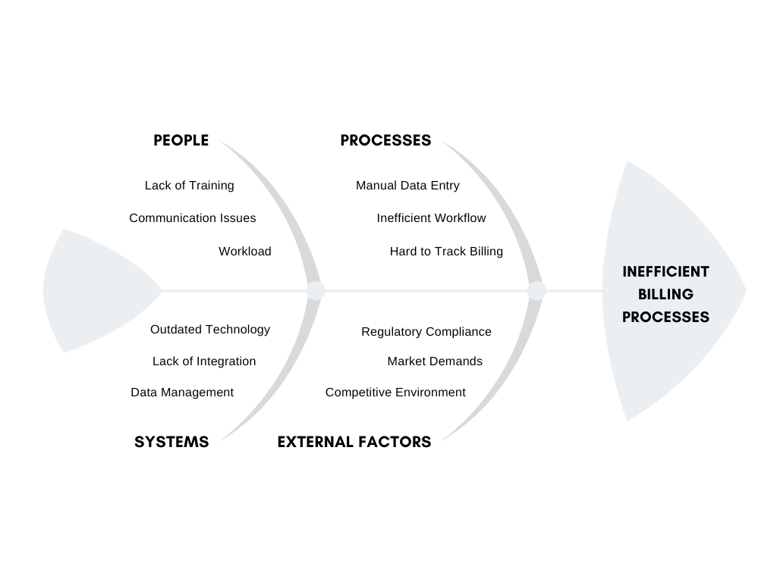

Fig. 1 Fishbone Diagram

The fishbone diagram, also known as an Ishikawa or cause-and-effect diagram, illustrates the various factors contributing to the inefficiencies in D&D I.T Networks and Data Solutions billing processes. It categorizes the root causes into four main areas: People, Processes, Systems, and External Factors.

# Proposed Solution

# 4.2 Lean Canvas

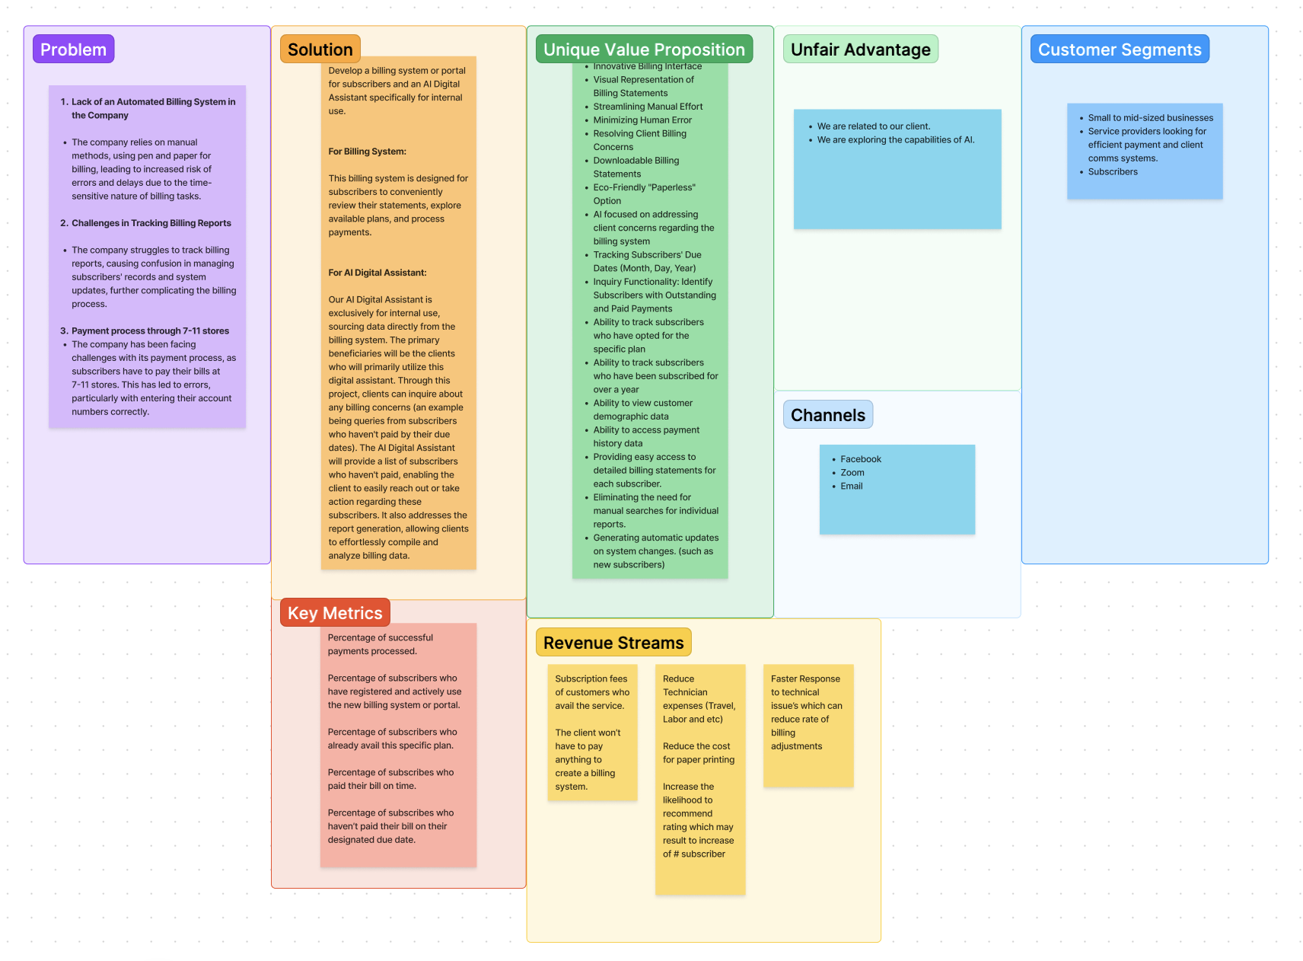

Fig. 2 Lean Canvas for D&D I.T Network and Data Solution

This project addresses inefficiencies due to the lack of a billing system, challenges in tracking billing reports, and payment processes by proposing a billing system and an internal AI Digital Assistant. These solutions aim to reduce errors, streamline billing, and enhance generated reports. The billing system will allow subscribers to explore available plans, view statements, and manage payments, while the AI Digital Assistant will handle internal billing inquiries and create billing reports. The unique value proposition focuses on visual statements, minimized errors, and comprehensive data access. Key metrics include successful payment processing and subscriber engagement. Revenue streams will come from subscription fees and cost savings. The target audience includes small to mid-sized businesses and service providers. Communication channels will include Facebook, Zoom, and email, all implemented at a standard cost. The goal is to improve billing efficiency, client satisfaction, and business growth for D&D I.T Network and Data Solution.

## 4.3 Product Vision

Table II

Product Vision

**For       D&D I.T Network and Data Solution**

| **Who** | Needs an efficient and automated billing system to reduce errors, delays, and inefficiencies in their current manual processes. |
| --- | --- |
| **The** | Subscriber Billing System and Internal AI Digital Assistant |
| **That** | Provides a user-friendly platform for subscribers to manage their accounts and an AI Digital Assistant for internal use to address billing concerns, identify overdue accounts, and generate billing reports efficiently. |
| **Unlike** | The current manual billing processes that are prone to errors, delays, and inefficiencies. |
| **Our Project** | Will improve transparency, empower customers to manage their accounts effectively, and enhance the reliability and efficiency of D&D I.T's services. The AI Digital Assistant will streamline internal operations, making it easier for the staff to manage billing data and take timely actions regarding overdue payments. |

## 4.4 Technology Specifications

1. **Open AI Account**

* **Type:** LLM (Large Language Model)
* **Purpose:** Developers choose OpenAI for its strong community and support, offering access to a network of researchers, engineers, and enthusiasts for valuable learning, troubleshooting, and collaboration. OpenAI's open-source contributions, including frameworks and tools, facilitate AI research and development, promoting collaboration and innovation. OpenAI makes it easy for developers to integrate AI into applications like text-based apps and chatbots. Founded in 2015, OpenAI is a leading research organization advancing AI for humanity's benefit, focusing on groundbreaking research and cutting-edge technologies like GPT, with a strong emphasis on safety and ethics.

2. **Frappe**

* **Type:** Framework
* **Purpose:** The developers choose Frappe as their framework for building complex, data-centric web applications, especially suited for enterprise systems that require advanced database management, workflows, and detailed permissions. Frappe provides a modular, low-code approach, simplifying the development and maintenance of these systems. It enables developers to manage CRUD operations with minimal custom code, design custom workflows and forms to streamline business processes, and configure complex permissions for precise access control. With Frappe, developers can also generate reports, visualize data through dashboards, and integrate with external systems using REST APIs, making it a flexible and powerful choice for creating scalable business applications like ERPNext.

3. **Laptop**

* **Type:** Hardware
* **Purpose:** This is to ensure that developers can create the objective smoothly, avoiding the aspect of system crash and latency issues.
* **Memory (RAM):** 8 GB
* **Operating System:** Windows 11

4. **Peopleware**

* Java Developer
* Product Designer
* QA Tester
* UI/UX Designer

## 4.5 Feasibility

## Operational Feasibility

## This part of the paper ensures that this system can handle changes in the system and will still be functional when applying new or updated functionalities or even adjustments for it to catch up with other competitors.

## 

## 1) *Operational Feasibility:* The new system will streamline operations, reduce errors, and improve customer satisfaction by offering a user-friendly platform for reviewing statements, exploring plans, and processing payments. The AI assistant will enhance internal efficiency by promptly addressing billing concerns and generating reports. This approach aims to minimize confusion and errors when using the system, ensuring its feasibility. Aligning with the company's mission and vision, this project supports long-term operational goals.

## 2) *Economic Feasibility:* This section details the evaluation of how the project or business idea can generate adequate benefits relative to its associated costs.

## 

## 

## 

## 

## Development Cost

## The development of this system will incur no charges as it is part of the Project-Based Learning program of Asia Pacific College, making it free of charge. Operational Cost Currently, the operational cost will include fees for the cloud SQL Server, as the system will manage and store necessary information. As well as the API costs for ChatGPT software that are needed for the system to function.

## Tangible benefits

By implementing this system at D&D I.T Network and Data Solutions, the company will experience an increase in revenue and subscribers since this will advertise the company's commitment to optimizing customer satisfaction and efficiency. The billing system, projected to reduce processing times by up to 95%, will attract new subscribers seeking efficient and transparent service. Additionally, the AI digital assistant will significantly improve internal efficiency by promptly addressing internal inquiries (improving response times by approximately 99%), tracking subscriber due dates, monitoring long-term customer relationships, and generating insightful reports.   
 **Intangible benefits**  
 Implementing this system would improve D&D I.T Networks and Data Solutions' overall reputation and boost employee retention and satisfaction by creating a positive and supportive environment. Additionally, it can strengthen customer trust and loyalty by showing our dedication to delivering excellent services to their company.

3) *Technical Feasibility:* From a technical perspective, the project is feasible given the current advancements in AI and billing system technologies. The development team will leverage existing technologies and tools to create a robust and scalable system. The technical expertise of the development team and the availability of necessary resources, such as software development tools and platforms, support the successful implementation of the project. The system's design will focus on user-friendliness, accuracy, and reliability.

4) *Schedule Feasibility:* The project timeline will be carefully planned to ensure timely completion. With clear objectives and a defined scope, the project will be divided into manageable phases: requirement analysis, design, development, testing, and deployment. Each phase will have specific milestones and deliverables, ensuring the project stays on track. Adequate time will be allocated for testing and user training to ensure a smooth transition and successful implementation.

# Requirements Analysis

## 

## V.1 Product Backlog / User Stories

Table III

Product Backlog

|  |  | **User stories** | |  |
| --- | --- | --- | --- | --- |
| **ID** | **As a…** | **I want to be able to…** | **So that…** | **Priority** |
| 1 | Staff | Open subscriber profile | I can check the subscriber billing statement | Must |
| 2 | Staff | Do account maintenance | I can update subscriber details/contacts | Must |
| 3 | Staff | Import billing statement | I can see the latest bill. | Must |
| 4 | Subscriber | Login | I can access my account. | Must |
| 5 | Subscriber | Download billing statement | I can have a e-copy of the bill | Should |
| 6 | Subscriber | Pay the bill | I can conveniently settle the balance. | Must |
| 7 | Subscriber | View Payment history | I can see the past payment history | Should |
| 8 | Subscriber | View account statement | I can see the entire balance. | Should |
| 9 | Subscriber | View homepage | I can explore and avail internet plans. | Could |
| 10 | Staff | Add Responses | I can add more functions | Could |
| 11 | Staff | Update database | I can maintain updated content | Must |
| 12 | Staff | Access control | I can delegate users to be able to edit the query/data | Should |
| 13 | Staff | View subscribers | We can check the statuses of their accounts. | Must |
| 14 | Staff | Filter Subscribers based on Due date | We can update/see if they are due for collection | Should |
| 15 | Staff | Filter Subscribers By last payment date | We can Identify non-paying subscribers. | Should |
| 16 | Staff | Export data | We can create reports and documents. | Should |
| 17 | Staff | Filter subscribers by subscription duration | We can view how long they have been subscribed. | Could |
| 18 | Staff | Filter subscribers who have already paid their bills | We can identify those with settled payments. | Could |

# V.2 Use Case Diagram

# Billing System

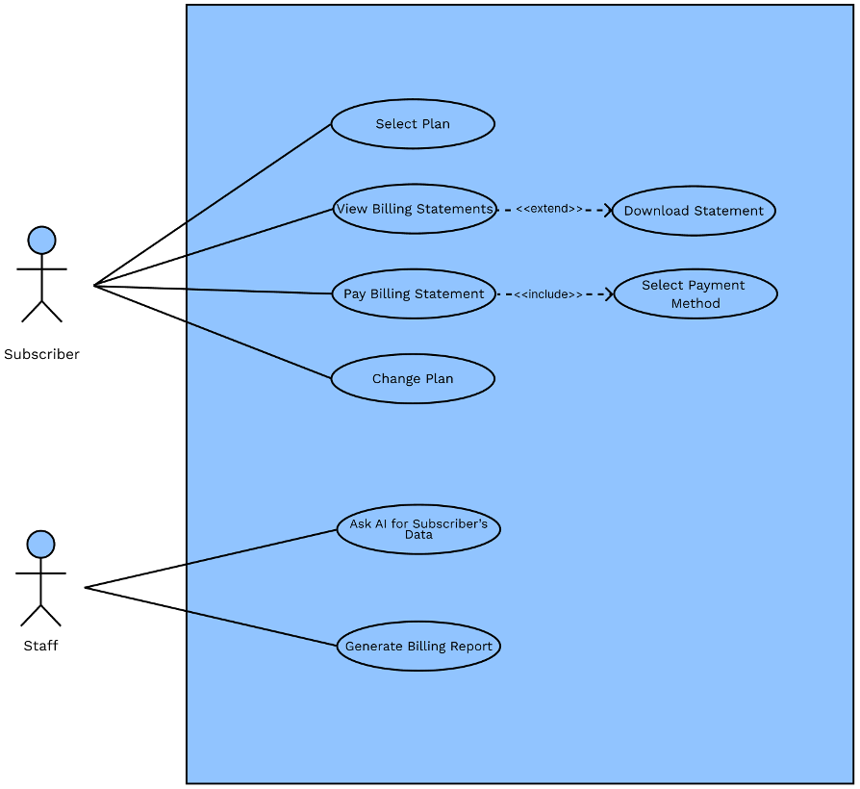

Fig. 3 Use Case Diagram

# V.3 Data Flow Diagram

# LEVEL 0

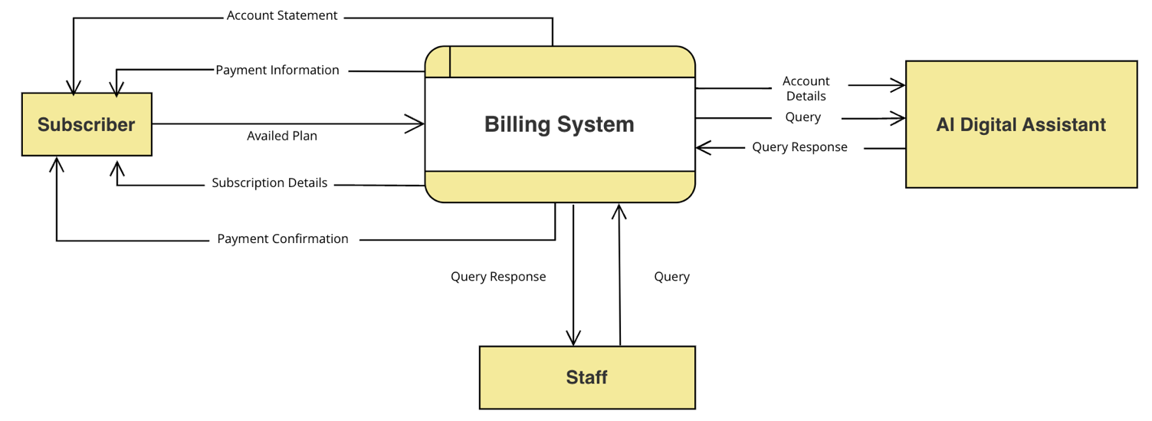

Fig. 4 Level 0 Data Flow Diagram

# 

# 

# 

# 

# 

# 

# 

# 

# 

# 

# 

# 

# 

# LEVEL 1

# 

# 

# 

Fig. 5 Level 1 Data Flow Diagram

# 

**LEVEL 2**

# Process 2.1

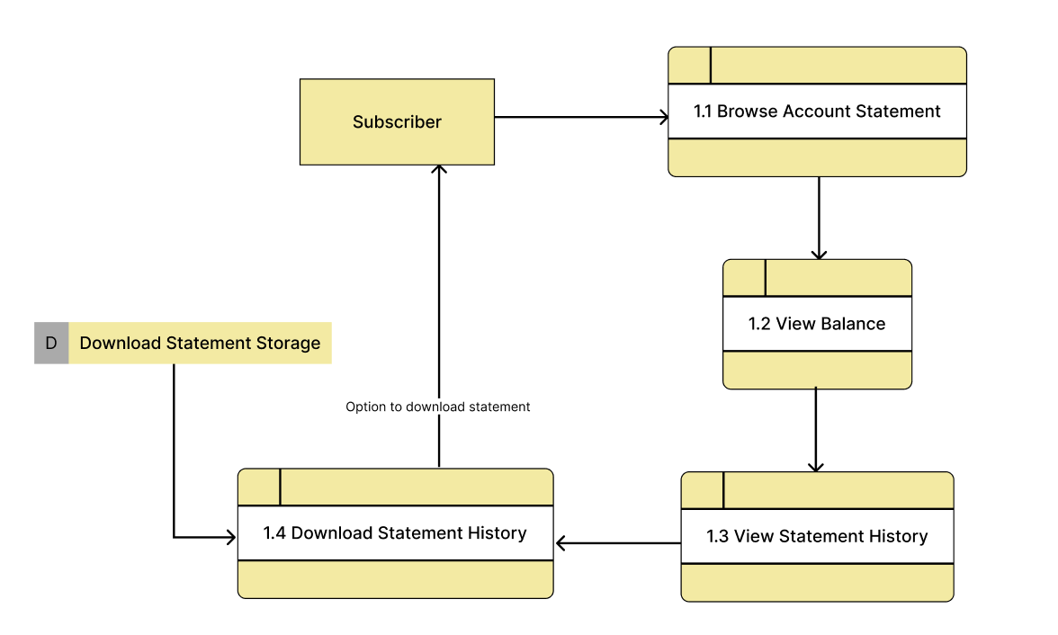

# 

# 

# Fig. 6 Level 2 Process 2.1 Data Flow Diagram

# Process 2.2

# 

# 

# 

# 

# Fig. 7 Level 2 Process 2.2 Data Flow Diagram

# Process 2.3

# 

# 

# Fig. 8 Level 2 Process 2.3 Data Flow Diagram

# 

# Process 2.4

# 

# Fig. 9 Level 2 Process 2.4 Data Flow Diagram

# 

# Process 2.5

# 

# 

# Fig. 10 Level 2 Process 2.5 Data Flow Diagram

# V.4 Fully Dressed Use Case

Table IV

Select Plan

| **Use Case ID:** | UC - 001 |
| --- | --- |
| **Use Case Name:** | Select Plan |
| **Created By:** | Elfa, Nekeisha Ashlyn E. |
| **Date Created:** | 24-8-2024 |
| **Description:** | This use case allows the subscriber to choose a new service plan from a list of available options provided by the system. Once a plan is selected, the system updates the subscriber’s account with the chosen plan. |
| **Primary Actor:** | Subscriber |
| **Secondary Actor:** | None |
| **Preconditions:** | * Subscriber is logged into the system. * The system has service plans available for selection. |
| **Postconditions:** | ● Subscriber's plan is updated in the system. |
| **Main Flow:** | 1. Subscriber navigates to the service plan page. 2. System displays the list of available service plans. 3. Subscriber reviews the available plans and selects a preferred service plan. 4. Subscriber clicks the "Continue" button to proceed with the selected plan. 5. System updates the subscriber's account with the selected plan. |

Table V

View Billing Statements

| **Use Case ID:** | UC - 002 |
| --- | --- |
| **Use Case Name:** | View Billing Statements |
| **Created By:** | Elfa, Nekeisha Ashlyn E. |
| **Date Created:** | 24-8-2024 |
| **Description:** | This use case allows the subscriber to access and review their billing statements. The subscriber navigates to the relevant section, selects a specific billing statement for a particular date, and views its details. Additionally, the system provides an option to download the statement if desired. |
| **Primary Actor:** | Subscriber |
| **Secondary Actor:** | None |
| **Preconditions:** | * Subscriber is logged into the system. * Billing statements are available for the subscriber. |
| **Postconditions:** | * Billing statements are displayed. * Subscriber can download the statement if desired. |
| **Main Flow:** | 1. Subscriber navigates to the “Account Statement” page to view their billing statement. 2. Subscriber selects a specific billing statement from the list of available statements. 3. System retrieves and displays the billing statement details for the selected period. 4. Subscriber reviews the billing statement. 5. System displays a "Download Statement" button. |
| **Extensions:** | 5A. The subscriber chooses to download the statement:     1. Subscriber clicks the download statement button. 2. System prepares the billing statement file for download. 3. System initiates the download process. 4. System confirms that the download is complete. 5. Subscriber accesses the downloaded file from their device. |

Table VI

Pay Billing Statement

| **Use Case ID:** | UC - 003 |
| --- | --- |
| **Use Case Name:** | Pay Billing Statement |
| **Created By:** | Monforte, Edgar Louise |
| **Date Created:** | 24-8-2024 |
| **Description:** | This use case allows the subscriber to pay their outstanding bill by selecting “Pay now,” reviewing the amount due, choosing a payment method, and entering payment details. The system processes the payment and displays a confirmation screen upon successful completion. |
| **Primary Actor:** | Subscriber |
| **Secondary Actor:** | Payment Gateway |
| **Preconditions:** | * Subscriber is logged into the system. * There is an outstanding balance on the subscriber’s account. |
| **Postconditions:** | ● Payment is processed successfully.  ● Subscriber receives a confirmation. |
| **Main Flow:** | 1. Subscriber selects the “Pay now” button. 2. System displays the amount due. 3. Subscriber reviews the amount due and selects a payment method. 4. System provides payment methods. 5. Subscriber enters the required payment details and submits the payment. 6. System processes the payment through the payment gateway. 7. System authenticates payment details. 8. System authorizes transactions. 9. System confirms payment. 10. Subscriber is shown a payment confirmation screen. |

Table VII

Change Plan

| **Use Case ID:** | UC - 004 | |
| --- | --- | --- |
| **Use Case Name:** | Change Plan | |
| **Created By:** | Monforte, Edgar Louise | |
| **Date Created:** | 24-8-2024 | |
| **Description:** | This use case allows the subscriber to switch from their current service plan to a new one after the completion of their existing plan. The system facilitates the process by displaying available plans, allowing the subscriber to select a new plan, and updating the account accordingly. | |
| **Primary Actor:** | Subscriber | |
| **Secondary Actor:** | None |  |
| **Preconditions:** | ● | Subscriber is logged into the system. |
|  | ● | Subscriber has a current active plan that can be changed. |
| **Postconditions:** | ● | The subscriber's plan is updated in the system. |
| **Main Flow:** | 1. | Subscriber completes their current plan and can now change to a new plan. |
|  | 2. | Subscriber navigates to the service plan page. |
|  | 3. | Subscriber reviews the available plans and selects a preferred service plan. |
|  | 4. | Subscriber clicks "Continue" to proceed with the selected service plan. |
|  | 5. | System updates the subscriber’s account with the new plan. |
|  | 6. | System displays a confirmation message to the subscriber. |

Table VIII

Set Status (Active/Inactive)

| **Use Case ID:** | UC - 005 | |
| --- | --- | --- |
| **Use Case Name:** | Set Status (Active/Inactive) | |
| **Created By:** | Monforte, Edgar Louise | |
| **Date Created:** | 24-8-2024 | |
| **Description:** | This use case allows staff to set the status of a subscriber's account to either active or inactive. | |
| **Primary Actor:** | Staff |  |
| **Secondary Actor:** | None |  |
| **Preconditions:** | ● | Staff is logged into the system with administrative privileges. |
|  | ● | The subscriber's account exists in the system. |
| **Postconditions:** | ● | Subscriber's status is updated in the system. |
| **Main Flow:** | 1. | Staff selects the "Set Status" option for a subscriber from the administrative interface. |
|  | 2. | Staff selects either Active or Inactive status. |
|  | 3. | System displays the current status of the subscriber. |
|  | 4. | The system updates the subscriber’s account status. |

Table IX

Ask AI for Subscriber’s Data

| **Use Case ID:** | UC - 006 |
| --- | --- |
| **Use Case Name:** | Ask AI for Subscriber’s Data |
| **Created By:** | Ditano, Abdul Hasheem O. |
| **Date Created:** | 24-8-2024 |
| **Description:** | This use case allows staff to query the AI assistant for subscriber data, apply filters such as billing due date, billing status, plan status, and account details. |
| **Primary Actor:** | Staff |
| **Secondary Actor:** | AI Digital Assistant |
| **Preconditions:** | ● Staff is logged into the system with sufficient permissions.  ● Subscriber’s data is available in the system for retrieval. |
| **Postconditions:** | * The requested data is displayed to the staff. * Any applied adjustments or credits are processed and logged. |
| **Main Flow:** | 1. The staff member begins by initiating a search for subscriber data. 2. They enter a search query, such as a subscriber’s name or account number. Additionally, they have the option to apply filters like billing due date, billing status, plan status, or account details by stating these criteria to the AI to narrow down the results. 3. After submitting the search, the AI assistant processes the query, applying the filters if any were chosen. 4. The system retrieves and presents the relevant subscriber data. 5. The AI system displays the filtered results to the staff. 6. The process concludes once the staff has completed their actions. |
| **Alternate Flow:** | 5A. Query Not Resolved     1. If the AI system cannot resolve the query, it informs the staff of the issue. 2. The staff is prompted to provide a more precise query or additional information to help the AI better understand and process the request. 3. The process concludes once the query is either resolved or escalated. |

Table X

Generate Billing Report

| **Use Case ID:** | UC - 007 | |
| --- | --- | --- |
| **Use Case Name:** | Generate Billing Report | |
| **Created By:** | Ditano, Abdul Hasheem O. | |
| **Date Created:** | 24-8-2024 | |
| **Description:** | This use case allows staff to send a query to the AI Assistant to generate a comprehensive billing report covering all data from the billing system. | |
| **Primary Actor:** | Staff |  |
| **Secondary Actor:** | None |  |
| **Preconditions:** | ● | Staff must be authenticated and authorized to generate billing reports. |
|  | ● | The AI Assistant must be operational and capable of accessing billing system data. |
| **Postconditions:** | ● | A billing report is generated and delivered to the staff. |
|  | ● | Staff may review the report as needed. |
| **Main Flow:** |  | A staff member submits a request to the AI Assistant to generate a billing report, which includes all data from the billing system. |
|  |  | The AI Assistant processes the request and generates the comprehensive billing report. |
|  |  | The AI Assistant delivers the generated billing report to the staff. |
|  |  | Staff reviews the report or take further actions based on the report's content. |
|  |  | The process concludes once the staff has reviewed and acted upon the report. |
| **Alternate Flow:** | 4A. Query Not Resolved     1. If the AI Assistant cannot process the request or encounters an error, it informs the staff of the issue. 2. The staff is prompted to refine the request by providing additional details or correcting any issues with the query. 3. The process concludes once the report is successfully generated. | |

# V.5 Test Cases

Table XI

Test Case

| Test Case ID | | TC - 001 - 01 | Test Case Description | | Verify that a subscriber can successfully select and update their service plan. | | | Version | | 2.1 |
| --- | --- | --- | --- | --- | --- | --- | --- | --- | --- | --- |
| Created By | | Elfa, Nekeisha Ashlyn E. | Reviewed By | |  | | |  | |  |
| QA Tester’s Log | | | | | Ensure the subscriber can select a service plan and the account updates correctly. Verify the confirmation message is accurate. | | | | | |
| Tester’s Name | |  | Date Tested | |  | | | Test Case  (Pass/Fail/Not) | |  |
| S # | | Prerequisites: | | | S # | Test Data | | | | |
| 1 | | Subscriber is logged into the system. | | | 1 | Subscriber account with access to service plan page. | | | | |
| 2 | | The system has service plans available for selection. | | | 2 | Available service plans list. | | | | |
| 3 | |  | | | 3 |  | | | | |
| Test Scenario | | | | | Validate the process of selecting a service plan and updating the account. | | | | | |
| Step # | Step Details | | | Expected Results | | | Actual Results | | Pass / Fail / Not executed / Suspend | |
| 1 | Navigate to the service plan page | | | Service plan page is displayed | | |  | |  | |
| 2 | Review the list of available service plans | | | List of service plans is visible | | |  | |  | |
| 3 | Select a preferred service plan | | | Selected plan is highlighted | | |  | |  | |
| 4 | Click the "Continue" button | | | System processes the selection | | |  | |  | |
| 5 | Verify account update | | | Subscriber’s account is updated with the selected plan | | |  | |  | |

Table XII

Test Case

| Test Case ID | | TC - 001 - 02 | Test Case Description | | Verify system behavior when the subscriber does not complete the plan selection process. | | | Version | | 2.1 |
| --- | --- | --- | --- | --- | --- | --- | --- | --- | --- | --- |
| Created By | | Elfa, Nekeisha Ashlyn E. | Reviewed By | |  | | |  | |  |
| QA Tester’s Log | | | | | Confirm the system does not update the account if the subscriber exits without completing the selection process. | | | | | |
| Tester’s Name | |  | Date Tested | |  | | | Test Case  (Pass/Fail/Not) | |  |
| S # | | Prerequisites: | | | S # | Test Data | | | | |
| 1 | | Subscriber is logged into the system. | | | 1 | Subscriber account with available service plans. | | | | |
| 2 | | The system has service plans available for selection. | | | 2 |  | | | | |
| 3 | |  | | | 3 |  | | | | |
| Test Scenario | | | | | Validate system response when the selection process is not completed. | | | | | |
| Step # | Step Details | | | Expected Results | | | Actual Results | | Pass / Fail / Not executed / Suspend | |
| 1 | Navigate to the service plan page | | | Service plan page is displayed | | |  | |  | |
| 2 | Review the list of available service plans | | | List of service plans is visible | | |  | |  | |
| 3 | Select a preferred service plan | | | Selected plan is highlighted | | |  | |  | |
| 4 | Do not click the "Continue" button and exit the page | | | System does not update the account | | |  | |  | |

Table XIII

Test Case

| Test Case ID | | TC - 002 - 01 | Test Case Description | | Verify that a subscriber can access and view a specific billing statement. | | | Version | | 2.1 |
| --- | --- | --- | --- | --- | --- | --- | --- | --- | --- | --- |
| Created By | | Elfa, Nekeisha Ashlyn E. | Reviewed By | |  | | |  | |  |
| QA Tester’s Log | | | | | The QA Tester ensures that the system allows the subscriber to view a specific billing statement. They will document whether the process successfully retrieves and displays the billing details or if any issues occur. | | | | | |
| Tester’s Name | |  | Date Tested | |  | | | Test Case  (Pass/Fail/Not) | |  |
| S # | | Prerequisites: | | | S # | Test Data | | | | |
| 1 | | Subscriber is logged into the system. | | | 1 | Subscriber account with multiple billing statements. | | | | |
| 2 | | Billing statements are available. | | | 2 | Billing statement for a specific date. | | | | |
| 3 | |  | | | 3 |  | | | | |
| Test Scenario | | | | | Validate the process of accessing and reviewing a billing statement. | | | | | |
| Step # | Step Details | | | Expected Results | | | Actual Results | | Pass / Fail / Not executed / Suspend | |
| 1 | Navigate to the “Account Statement” page | | | System displays the list of available billing statements | | |  | |  | |
| 2 | Select a billing statement for a specific date | | | System displays the details of the selected billing statement | | |  | |  | |
| 3 | Review the billing statement | | | Billing details are clear and correct | | |  | |  | |

Table XIV

Test Case

| Test Case ID | | TC - 002 - 02 | Test Case Description | | Verify that a subscriber can download a billing statement after viewing it. | | | Version | | 2.1 |
| --- | --- | --- | --- | --- | --- | --- | --- | --- | --- | --- |
| Created By | | Elfa, Nekeisha Ashlyn E. | Reviewed By | |  | | |  | |  |
| QA Tester’s Log | | | | | The QA Tester will check if the download feature works correctly, ensuring the system prepares the file, completes the download, and the subscriber can access the file without issues. | | | | | |
| Tester’s Name | |  | Date Tested | |  | | | Test Case  (Pass/Fail/Not) | |  |
| S # | | Prerequisites: | | | S # | Test Data | | | | |
| 1 | | Subscriber is logged into the system. | | | 1 | Subscriber account with a selected billing statement for download. | | | | |
| 2 | | Billing statement is available for the specific date. | | | 2 |  | | | | |
| 3 | |  | | | 3 |  | | | | |
| Test Scenario | | | | |  | | | | | |
| Step # | Step Details | | | Expected Results | | | Actual Results | | Pass / Fail / Not executed / Suspend | |
| 1 | View a billing statement | | | System displays the billing details for the selected period | | |  | |  | |
| 2 | Click the "Download Statement" button | | | System prepares the billing statement for download | | |  | |  | |
| 3 | Verify the download process | | | The billing statement file is successfully downloaded | | |  | |  | |
| 4 | Access the downloaded billing statement | | | The file is accessible and correct | | |  | |  | |

Table XV

Test Case

| Test Case ID | | TC - 002 - 03 | Test Case Description | | Verify system behavior when no billing statements are available for the subscriber. | | | Version | | 2.1 |
| --- | --- | --- | --- | --- | --- | --- | --- | --- | --- | --- |
| Created By | | Elfa, Nekeisha Ashlyn E. | Reviewed By | |  | | |  | |  |
| QA Tester’s Log | | | | | The QA Tester will verify if the system correctly handles a scenario where no billing statements are available and whether an appropriate message is displayed to the subscriber. | | | | | |
| Tester’s Name | |  | Date Tested | |  | | | Test Case  (Pass/Fail/Not) | |  |
| S # | | Prerequisites: | | | S # | Test Data | | | | |
| 1 | | Subscriber is logged into the system. | | | 1 | Subscriber account with no billing statements. | | | | |
| 2 | | No billing statements are available. | | | 2 |  | | | | |
| 3 | |  | | | 3 |  | | | | |
| Test Scenario | | | | |  | | | | | |
| Step # | Step Details | | | Expected Results | | | Actual Results | | Pass / Fail / Not executed / Suspend | |
| 1 | Navigate to the “Account Statement” page | | | System displays a message indicating no available billing statements | | |  | |  | |

Table XVI

Test Case

| Test Case ID | | TC - 003 - 01 | Test Case Description | | Test successful payment process with valid GCash payment details. | | Version | | 2.1 |
| --- | --- | --- | --- | --- | --- | --- | --- | --- | --- |
| Created By | | Monforte, Edgar Louise | Reviewed By | |  | |  | |  |
| QA Tester’s Log | | | | | Ensure that the payment process completes successfully using GCash. Verify that the amount due is correctly displayed, and the payment confirmation is accurately generated and shown to the subscriber. | | | | |
| Tester’s Name | |  | Date Tested | |  | | Test Case  (Pass/Fail/Not) | |  |
| S # | | Prerequisites: | | | S # | Test Data | | | |
| 1 | | Subscriber is logged into the system. | | | 1 | Outstanding balance amount: 5,000php | | | |
| 2 | | There is an outstanding balance on the subscriber’s account. | | | 2 | Payment method: GCash | | | |
| 3 | |  | | | 3 | Payment details: Valid GCash account credentials | | | |
| 4 | |  | | | 4 |  | | | |
| Test Scenario | | | | | Verify that a subscriber can successfully complete a payment using GCash and that the payment confirmation is accurately reflected. | | | | |
| Step # | Step Details | | | Expected Results | | Actual Results | | Pass / Fail / Not executed / Suspend | |
| 1 | Subscriber selects the “Pay now” button. | | | System displays the amount due. | |  | |  | |
| 2 | System displays the amount due. | | | Amount due is correctly displayed. | |  | |  | |
| 3 | Subscriber reviews the amount due and selects GCash as the payment method. | | | System displays GCash payment option. | |  | |  | |
| 4 | Subscriber enters valid GCash payment details and submits. | | | System validates and processes payment details. | |  | |  | |
| 5 | System processes the payment through the payment gateway and confirms the payment. | | | Payment confirmation screen is displayed to the subscriber. | |  | |  | |
| 6 | Subscriber reviews the payment confirmation screen. | | | Confirmation details match the submitted payment. | |  | |  | |

Table XV

Test Case

| Test Case ID | | TC - 003 - 02 | Test Case Description | | Test payment process when the GCash payment method is unavailable. | | Version | | 2.1 |
| --- | --- | --- | --- | --- | --- | --- | --- | --- | --- |
| Created By | | Monforte, Edgar Louise | Reviewed By | |  | |  | |  |
| QA Tester’s Log | | | | | Ensure that the system correctly identifies the unavailability of GCash and prompts the subscriber to select an alternative payment method. Verify that error messages are appropriately displayed. | | | | |
| Tester’s Name | |  | Date Tested | |  | | Test Case  (Pass/Fail/Not) | |  |
| S # | | Prerequisites: | | | S # | Test Data | | | |
| 1 | | Subscriber is logged into the system. | | | 1 | Outstanding balance amount: 5,000php | | | |
| 2 | | There is an outstanding balance on the subscriber’s account. | | | 2 | Payment method: GCash (unavailable) | | | |
| 3 | |  | | | 3 | Payment details: N/A | | | |
| 4 | |  | | | 4 |  | | | |
| Test Scenario | | | | | Verify that when GCash is unavailable, the system prompts the subscriber to choose an alternative payment method and that this process functions correctly. | | | | |
| Step # | Step Details | | | Expected Results | | Actual Results | | Pass / Fail / Not executed / Suspend | |
| 1 | Subscriber selects the “Pay now” button. | | | System displays the amount due. | |  | |  | |
| 2 | System displays the amount due. | | | Amount due is correctly displayed. | |  | |  | |
| 3 | Subscriber attempts to select GCash as the payment method. | | | System indicates GCash payment method is unavailable. | |  | |  | |
| 4 | System displays an error message about GCash unavailability. | | | Error message for unavailable payment method is shown. | |  | |  | |
| 5 | Subscriber selects an alternative payment method. | | | Alternative payment methods are presented to the subscriber. | |  | |  | |
| 6 | Subscriber enters valid payment details for the alternative method and submits. | | | System processes the payment using the alternative method. | |  | |  | |
| 7 | System confirms payment and displays confirmation screen. | | | Payment confirmation screen is displayed with correct details. | |  | |  | |

Table XVI

Test Case

| Test Case ID | | TC - 003 - 03 | Test Case Description | | Test payment process with invalid GCash payment details. | | Version | | 2.1 |
| --- | --- | --- | --- | --- | --- | --- | --- | --- | --- |
| Created By | | Monforte, Edgar Louise | Reviewed By | |  | |  | |  |
| QA Tester’s Log | | | | | Ensure that the system correctly handles invalid GCash payment details by displaying appropriate error messages and preventing payment processing. | | | | |
| Tester’s Name | |  | Date Tested | |  | | Test Case  (Pass/Fail/Not) | |  |
| S # | | Prerequisites: | | | S # | Test Data | | | |
| 1 | | Subscriber is logged into the system. | | | 1 | Outstanding balance amount: 5,000php | | | |
| 2 | | There is an outstanding balance on the subscriber’s account. | | | 2 | Payment method: GCash (unavailable) | | | |
| 3 | |  | | | 3 | Invalid GCash account credentials | | | |
| 4 | |  | | | 4 |  | | | |
| Test Scenario | | | | | Verify that when invalid GCash payment details are entered, the system displays an appropriate error message and prevents the payment from being processed. | | | | |
| Step # | Step Details | | | Expected Results | | Actual Results | | Pass / Fail / Not executed / Suspend | |
| 1 | Subscriber selects the “Pay now” button. | | | System displays the amount due. | |  | |  | |
| 2 | System displays the amount due. | | | Amount due is correctly displayed. | |  | |  | |
| 3 | Subscriber selects GCash as the payment method. | | | System displays GCash payment option. | |  | |  | |
| 4 | Subscriber enters invalid GCash payment details and submits. | | | System fails to validate the payment details. | |  | |  | |
| 5 | System displays an error message for invalid payment details. | | | Error message for invalid details is shown. | |  | |  | |
| 6 | Subscriber is prompted to re-enter valid payment details. | | | Prompt for re-entry of payment details is displayed. | |  | |  | |
| 7 | Subscriber re-enters valid payment details and submits. | | | System validates and processes the payment correctly. | |  | |  | |

Table XVII

Test Case

| Test Case ID | | TC - 004 - 01 | Test Case Description | | Test the process of changing to a new plan after the completion of the current plan. | | Version | | 2.1 |
| --- | --- | --- | --- | --- | --- | --- | --- | --- | --- |
| Created By | | Monforte, Edgar Louise | Reviewed By | |  | |  | |  |
| QA Tester’s Log | | | | | Ensure that the subscriber can successfully change their plan after the current plan ends. Verify that the new plan is correctly updated in the system and that a confirmation message is displayed. | | | | |
| Tester’s Name | |  | Date Tested | |  | | Test Case  (Pass/Fail/Not) | |  |
| S # | | Prerequisites: | | | S # | Test Data | | | |
| 1 | | Subscriber is logged into the system. | | | 1 | Current plan: Plan 1000 | | | |
| 2 | | Subscriber’s current plan, Plan 1000, has been completed. | | | 2 | New plan: Plan 1400 | | | |
| 3 | |  | | | 3 |  | | | |
| 4 | |  | | | 4 |  | | | |
| Test Scenario | | | | | Verify that the subscriber can successfully change to a new service plan and that the system updates the account and displays a confirmation message. | | | | |
| Step # | Step Details | | | Expected Results | | Actual Results | | Pass / Fail / Not executed / Suspend | |
| 1 | Subscriber completes their current plan, Plan 1000. | | | Current plan status is updated to completed. | |  | |  | |
| 2 | Subscriber navigates to the service plan page. | | | Service plan page is displayed. | |  | |  | |
| 3 | Subscriber reviews the available plans. | | | Available plans are listed and visible. | |  | |  | |
| 4 | Subscriber selects the Plan 1400 and clicks "Continue." | | | System processes the selection of the Plan 1400. | |  | |  | |
| 5 | System updates the subscriber’s account with the new plan. | | | Subscriber’s account now shows the 1400. | |  | |  | |
| 6 | System displays a confirmation message to the subscriber. | | | Confirmation message is displayed with the new plan details. | |  | |  | |

Table XVIII

Test Case

| Test Case ID | | TC - 004 - 02 | Test Case Description | | Test the scenario where no plans are available for selection when the subscriber attempts to change plans. | | Version | | 2.1 |
| --- | --- | --- | --- | --- | --- | --- | --- | --- | --- |
| Created By | | Monforte, Edgar Louise | Reviewed By | |  | |  | |  |
| QA Tester’s Log | | | | | Ensure that the system handles the situation where no plans are available, providing an appropriate message to the subscriber. | | | | |
| Tester’s Name | |  | Date Tested | |  | | Test Case  (Pass/Fail/Not) | |  |
| S # | | Prerequisites: | | | S # | Test Data | | | |
| 1 | | Subscriber is logged into the system. | | | 1 | Current plan: Plan 1000 | | | |
| 2 | | Subscriber’s current plan, Plan 1000, has been completed. | | | 2 |  | | | |
| 3 | | No new plans are available for selection. | | | 3 |  | | | |
| 4 | |  | | | 4 |  | | | |
| Test Scenario | | | | | Verify that when no new plans are available, the system informs the subscriber appropriately. | | | | |
| Step # | Step Details | | | Expected Results | | Actual Results | | Pass / Fail / Not executed / Suspend | |
| 1 | Subscriber completes their current plan, Plan 1000. | | | Current plan status is updated to completed. | |  | |  | |
| 2 | Subscriber navigates to the service plan page. | | | Service plan page is displayed. | |  | |  | |
| 3 | Subscriber reviews the available plans. | | | No plans are available for selection. | |  | |  | |
| 4 | Subscriber selects the Plan 1400 and clicks "Continue." | | | Appropriate message is shown to the subscriber. | |  | |  | |
| 5 | System displays a message indicating no available plans. | | | Instructions for alternative actions are provided. | |  | |  | |

Table XIX

Test Case

| Test Case ID | | TC - 005 - 01 | Test Case Description | | Test the process of setting a subscriber's account status to Active. | | Version | | 2.1 |
| --- | --- | --- | --- | --- | --- | --- | --- | --- | --- |
| Created By | | Monforte, Edgar Louise | Reviewed By | |  | |  | |  |
| QA Tester’s Log | | | | | Ensure that the staff can successfully set a subscriber’s status to Active. Verify that the system updates the status correctly and that the change is reflected in the system. | | | | |
| Tester’s Name | |  | Date Tested | |  | | Test Case  (Pass/Fail/Not) | |  |
| S # | | Prerequisites: | | | S # | Test Data | | | |
| 1 | | Staff is logged into the system with administrative privileges. | | | 1 | Subscriber ID: 012345 | | | |
| 2 | | The subscriber's account exists in the system. | | | 2 | New status: Active | | | |
| 3 | |  | | | 3 |  | | | |
| 4 | |  | | | 4 |  | | | |
| Test Scenario | | | | | Verify that the subscriber's status can be successfully changed to Active and that the system reflects this update. | | | | |
| Step # | Step Details | | | Expected Results | | Actual Results | | Pass / Fail / Not executed / Suspend | |
| 1 | Staff selects the "Set Status" option for the subscriber from the administrative interface. | | | "Set Status" option is accessible and selectable. | |  | |  | |
| 2 | Staff selects "Active" status. | | | "Active" status is selected. | |  | |  | |
| 3 | System displays the current status of the subscriber. | | | Current status is displayed. | |  | |  | |
| 4 | Staff confirms the status change to "Active." | | | Status change is confirmed. | |  | |  | |
| 5 | System updates the subscriber’s account status to Active. | | | Subscriber’s status is updated to Active. | |  | |  | |
| 6 | Staff verifies the status update. | | | Status change is correctly reflected in the system. | |  | |  | |

Table XX

Test Case

| Test Case ID | | TC - 005 - 02 | Test Case Description | | Test the process of setting a subscriber's account status to Inactive. | | Version | | 2.1 |
| --- | --- | --- | --- | --- | --- | --- | --- | --- | --- |
| Created By | | Monforte, Edgar Louise | Reviewed By | |  | |  | |  |
| QA Tester’s Log | | | | | Ensure that the staff can successfully set a subscriber’s status to Inactive. Verify that the system updates the status correctly and that the change is reflected in the system. | | | | |
| Tester’s Name | |  | Date Tested | |  | | Test Case  (Pass/Fail/Not) | |  |
| S # | | Prerequisites: | | | S # | Test Data | | | |
| 1 | | Staff is logged into the system with administrative privileges. | | | 1 | Subscriber ID: 067890 | | | |
| 2 | | The subscriber's account exists in the system. | | | 2 | New status: Inactive | | | |
| 3 | |  | | | 3 |  | | | |
| 4 | |  | | | 4 |  | | | |
| Test Scenario | | | | | Verify that the subscriber's status can be successfully changed to Inactive and that the system reflects this update. | | | | |
| Step # | Step Details | | | Expected Results | | Actual Results | | Pass / Fail / Not executed / Suspend | |
| 1 | Staff selects the "Set Status" option for the subscriber from the administrative interface. | | | "Set Status" option is accessible and selectable. | |  | |  | |
| 2 | Staff selects "Inactive" status. | | | "Inactive" status is selected. | |  | |  | |
| 3 | System displays the current status of the subscriber. | | | Current status is displayed. | |  | |  | |
| 4 | Staff confirms the status change to "Inactive." | | | Status change is confirmed. | |  | |  | |
| 5 | System updates the subscriber’s account status to Inactive. | | | Subscriber’s status is updated to Inactive. | |  | |  | |
| 6 | Staff verifies the status update. | | | Status change is correctly reflected in the system. | |  | |  | |

Table XXI

Test Case

| Test Case ID | | TC - 005 - 03 | Test Case Description | | Test the scenario where staff attempts to set the status for a subscriber with an invalid ID. | | Version | | 2.1 |
| --- | --- | --- | --- | --- | --- | --- | --- | --- | --- |
| Created By | | Monforte, Edgar Louise | Reviewed By | |  | |  | |  |
| QA Tester’s Log | | | | | Ensure that the system handles invalid subscriber IDs appropriately, displaying an error message and not updating the status. | | | | |
| Tester’s Name | |  | Date Tested | |  | | Test Case  (Pass/Fail/Not) | |  |
| S # | | Prerequisites: | | | S # | Test Data | | | |
| 1 | | Staff is logged into the system with administrative privileges. | | | 1 | Invalid Subscriber ID: 091989 | | | |
| 2 | | An invalid subscriber ID is used. | | | 2 | New status: Active | | | |
| 3 | |  | | | 3 |  | | | |
| 4 | |  | | | 4 |  | | | |
| Test Scenario | | | | | Verify that when an invalid subscriber ID is used, the system displays an error message and does not attempt to update the status. | | | | |
| Step # | Step Details | | | Expected Results | | Actual Results | | Pass / Fail / Not executed / Suspend | |
| 1 | Staff selects the "Set Status" option for a subscriber with an invalid ID. | | | System identifies the invalid subscriber ID. | |  | |  | |
| 2 | Staff selects "Active" status for the invalid subscriber ID. | | | System detects the invalid ID. | |  | |  | |
| 3 | System displays an error message indicating an invalid subscriber ID. | | | Error message is displayed. | |  | |  | |
| 4 | Staff confirms the error message. | | | Confirmation of error handling is provided. | |  | |  | |
| 5 | No status update is made for the invalid subscriber ID. | | | No change occurs in the system. | |  | |  | |

Table XXII

Test Case

| Test Case ID | | TC - 005 - 04 | Test Case Description | | Test the scenario where a system error occurs during the status update process. | | Version | | 2.1 |
| --- | --- | --- | --- | --- | --- | --- | --- | --- | --- |
| Created By | | Monforte, Edgar Louise | Reviewed By | |  | |  | |  |
| QA Tester’s Log | | | | | Ensure that the system correctly handles errors during the status update process, providing an appropriate error message and preventing incomplete updates. | | | | |
| Tester’s Name | |  | Date Tested | |  | | Test Case  (Pass/Fail/Not) | |  |
| S # | | Prerequisites: | | | S # | Test Data | | | |
| 1 | | Staff is logged into the system with administrative privileges. | | | 1 | Subscriber ID: 012345 | | | |
| 2 | | Subscriber's account exists in the system. | | | 2 | New status: Active (simulate error during update) | | | |
| 3 | | A simulated system error occurs during the status update. | | | 3 |  | | | |
| 4 | |  | | | 4 |  | | | |
| Test Scenario | | | | | Verify that when a system error occurs during the status update process, the staff is informed and the system prevents incomplete updates. | | | | |
| Step # | Step Details | | | Expected Results | | Actual Results | | Pass / Fail / Not executed / Suspend | |
| 1 | Staff selects the "Set Status" option for a subscriber with an invalid ID. | | | "Set Status" option is accessible. | |  | |  | |
| 2 | Staff selects "Active" status for the invalid subscriber ID. | | | "Active" status is selected. | |  | |  | |
| 3 | Simulate a system error during the update process. | | | System displays an error message about the failure. | |  | |  | |
| 4 | Staff is informed of the error and instructed to try again. | | | Error message and retry instructions are displayed. | |  | |  | |
| 5 | Staff attempts to update the status again. | | | System attempts to process the status update again. | |  | |  | |

Table XXIII

Test Case

| Test Case ID | | TC - 006 - 001 | Test Case Description | | Verify that staff can query the AI assistant for subscriber data by entering the account number. | | | Version | | 2.1 |
| --- | --- | --- | --- | --- | --- | --- | --- | --- | --- | --- |
| Created By | | Ditano, Abdul Hasheem O. | Reviewed By | |  | | |  | |  |
| QA Tester’s Log | | | | | The QA Tester ensures that the system retrieves the correct subscriber data based on the account number provided. They will verify that the AI assistant returns accurate and complete results. | | | | | |
| Tester’s Name | |  | Date Tested | |  | | | Test Case  (Pass/Fail/Not) | |  |
| S # | | Prerequisites: | | | S # | Test Data | | | | |
| 1 | | Staff is logged into the system with sufficient permissions. | | | 1 | Subscriber account number: [Sample Account Number] | | | | |
| 2 | | Subscriber data is available for the specific account number. | | | 2 |  | | | | |
| 3 | |  | | | 3 |  | | | | |
| Test Scenario | | | | | Verify that staff can retrieve subscriber data by querying the account number. | | | | | |
| Step # | Step Details | | | Expected Results | | | Actual Results | | Pass / Fail / Not executed / Suspend | |
| 1 | Staff initiates a search by entering a subscriber's account number. | | | The AI assistant processes the query and retrieves the data. | | |  | |  | |
| 2 | The AI assistant displays the subscriber's data on screen. | | | Subscriber data, including account details, is displayed accurately. | | |  | |  | |

Table XXIV

Test Case

| Test Case ID | | TC - 006 - 002 | Test Case Description | | Verify that staff can apply filters such as billing status and due date to narrow down the search results. | | | Version | | 2.1 |
| --- | --- | --- | --- | --- | --- | --- | --- | --- | --- | --- |
| Created By | | Ditano, Abdul Hasheem O. | Reviewed By | |  | | |  | |  |
| QA Tester’s Log | | | | | The QA Tester will confirm that the AI assistant applies the selected filters (billing status and due date) and returns results that match the specified criteria. Testing should ensure proper filtering behavior and correct display of data. | | | | | |
| Tester’s Name | |  | Date Tested | |  | | | Test Case  (Pass/Fail/Not) | |  |
| S # | | Prerequisites: | | | S # | Test Data | | | | |
| 1 | | Staff is logged into the system with sufficient permissions. | | | 1 | Billing status: "Unpaid" | | | | |
| 2 | | Subscriber data includes varying billing statuses and due dates. | | | 2 | Due date: [Sample Due Date] | | | | |
| 3 | |  | | | 3 |  | | | | |
| Test Scenario | | | | | Validate filtering functionality by applying billing status and due date filters. | | | | | |
| Step # | Step Details | | | Expected Results | | | Actual Results | | Pass / Fail / Not executed / Suspend | |
| 1 | Staff enters a query and applies filters for billing status and due date. | | | The AI assistant processes the query and applies the filters. | | |  | |  | |
| 2 | AI assistant displays the filtered subscriber data. | | | Only subscribers matching the billing status and due date filters are displayed. | | |  | |  | |

Table XXV

Test Case

| Test Case ID | | TC - 006 - 003 | Test Case Description | | Verify system behavior when the AI assistant cannot resolve a query. | | | Version | | 2.1 |
| --- | --- | --- | --- | --- | --- | --- | --- | --- | --- | --- |
| Created By | | Ditano, Abdul Hasheem O. | Reviewed By | |  | | |  | |  |
| QA Tester’s Log | | | | | The QA Tester will test the AI assistant's response when a query cannot be resolved. They will verify that an error message is displayed and that the staff is prompted to refine the search query or provide additional information. | | | | | |
| Tester’s Name | |  | Date Tested | |  | | | Test Case  (Pass/Fail/Not) | |  |
| S # | | Prerequisites: | | | S # | Test Data | | | | |
| 1 | | Staff is logged into the system with sufficient permissions. | | | 1 | Invalid account number or criteria leading to an unresolved query. | | | | |
| 2 | | Query submitted cannot be resolved by the AI assistant. | | | 2 |  | | | | |
| 3 | |  | | | 3 |  | | | | |
| Test Scenario | | | | | Check how the system handles unresolved queries and prompts the user to refine the search. | | | | | |
| Step # | Step Details | | | Expected Results | | | Actual Results | | Pass / Fail / Not executed / Suspend | |
| 1 | Staff submits a query that the AI assistant cannot resolve. | | | The AI assistant informs the staff of the issue and provides a message. | | |  | |  | |
| 2 | Staff is prompted to refine the query or provide additional information. | | | System displays appropriate prompts to guide the user in refining the search. | | |  | |  | |

Table XXVII

Test Case

| Test Case ID | | TC - 007 - 001 | Test Case Description | | Verify that the AI Assistant can generate a comprehensive billing report from the billing system data when requested by the staff. | | | Version | | 2.1 |
| --- | --- | --- | --- | --- | --- | --- | --- | --- | --- | --- |
| Created By | | Ditano, Abdul Hasheem O. | Reviewed By | |  | | |  | |  |
| QA Tester’s Log | | | | | The QA Tester will ensure that the AI Assistant successfully retrieves and compiles the entire billing report from the system. This includes verifying the accuracy and completeness of the report generated. | | | | | |
| Tester’s Name | |  | Date Tested | |  | | | Test Case  (Pass/Fail/Not) | |  |
| S # | | Prerequisites: | | | S # | Test Data | | | | |
| 1 | | Staff is logged into the system with sufficient permissions to request reports. | | | 1 | Billing system containing comprehensive billing data. | | | | |
| 2 | | AI Assistant has access to all billing system data. | | | 2 |  | | | | |
| 3 | |  | | | 3 |  | | | | |
| Test Scenario | | | | | Verify that the AI Assistant processes the staff's query and generates a complete billing report. | | | | | |
| Step # | Step Details | | | Expected Results | | | Actual Results | | Pass / Fail / Not executed / Suspend | |
| 1 | Staff sends a request to the AI Assistant to generate a billing report. | | | The AI Assistant acknowledges the request and begins processing the report. | | |  | |  | |
| 2 | AI Assistant retrieves and compiles data from the billing system. | | | AI Assistant successfully processes the entire billing data. | | |  | |  | |
| 3 | AI Assistant generates and delivers the report to the staff. | | | Report is displayed or made available to the staff for review. | | |  | |  | |

Table XXVIII

Test Case

| Test Case ID | | TC - 007 - 002 | Test Case Description | | Verify how the AI Assistant handles cases where it cannot process the billing report request. | | | Version | | 2.1 |
| --- | --- | --- | --- | --- | --- | --- | --- | --- | --- | --- |
| Created By | | Ditano, Abdul Hasheem O. | Reviewed By | |  | | |  | |  |
| QA Tester’s Log | | | | | The QA Tester will ensure that when the AI Assistant cannot resolve the query for generating a billing report, it provides an error message and prompts staff to refine the request or provide additional details. | | | | | |
| Tester’s Name | |  | Date Tested | |  | | | Test Case  (Pass/Fail/Not) | |  |
| S # | | Prerequisites: | | | S # | Test Data | | | | |
| 1 | | AI Assistant is operational but cannot process the current request due to incomplete or invalid input. | | | 1 | Invalid or incomplete billing report request. | | | | |
| 2 | |  | | | 2 |  | | | | |
| 3 | |  | | | 3 |  | | | | |
| Test Scenario | | | | | Check how the system manages unresolved queries and prompts the staff to refine the request. | | | | | |
| Step # | Step Details | | | Expected Results | | | Actual Results | | Pass / Fail / Not executed / Suspend | |
| 1 | Staff sends a request to the AI Assistant that cannot be processed (e.g., missing details). | | | AI Assistant returns an error message and informs the staff of the issue. | | |  | |  | |
| 2 | Staff is prompted to refine the query or provide additional information. | | | System displays appropriate instructions for refining the request. | | |  | |  | |
| 3 | Staff refines the query and resubmits the request. | | | AI Assistant successfully processes the refined request and generates the report. | | |  | |  | |

# 

# V.6 Activity Diagram with Swimlanes

# Select Plan

# 

# 

# 

# Fig. 11 Select Plan Activity Diagram with Swimlanes

# 

# View Billing Statements

# 

# Fig. 12 View Billing Statements Activity Diagram with Swimlanes

# Pay the Bill

Fig. 13 Pay the Bill Activity Diagram with Swimlanes

# Change Plan

# Fig. 14 Change Plan Activity Diagram with Swimlanes

# Set Status (Active/Inactive)

Fig. 15 Set Status Activity Diagram with Swimlanes

# Ask AI for Subscriber's Data

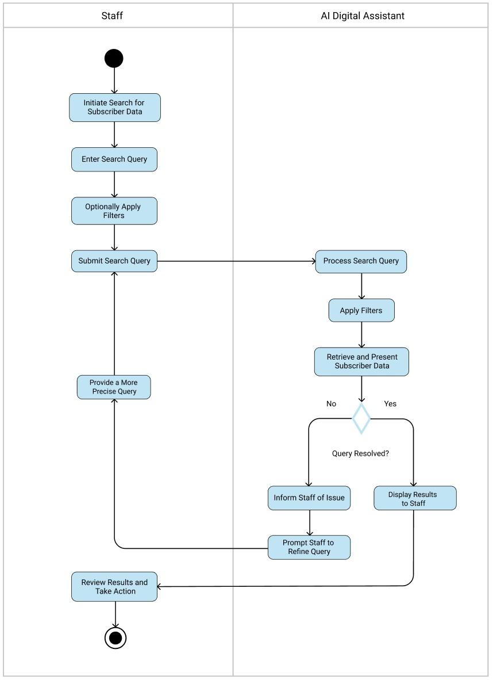

# Fig. 16 Ask AI Activity Diagram with Swimlanes

# Generate Billing Report

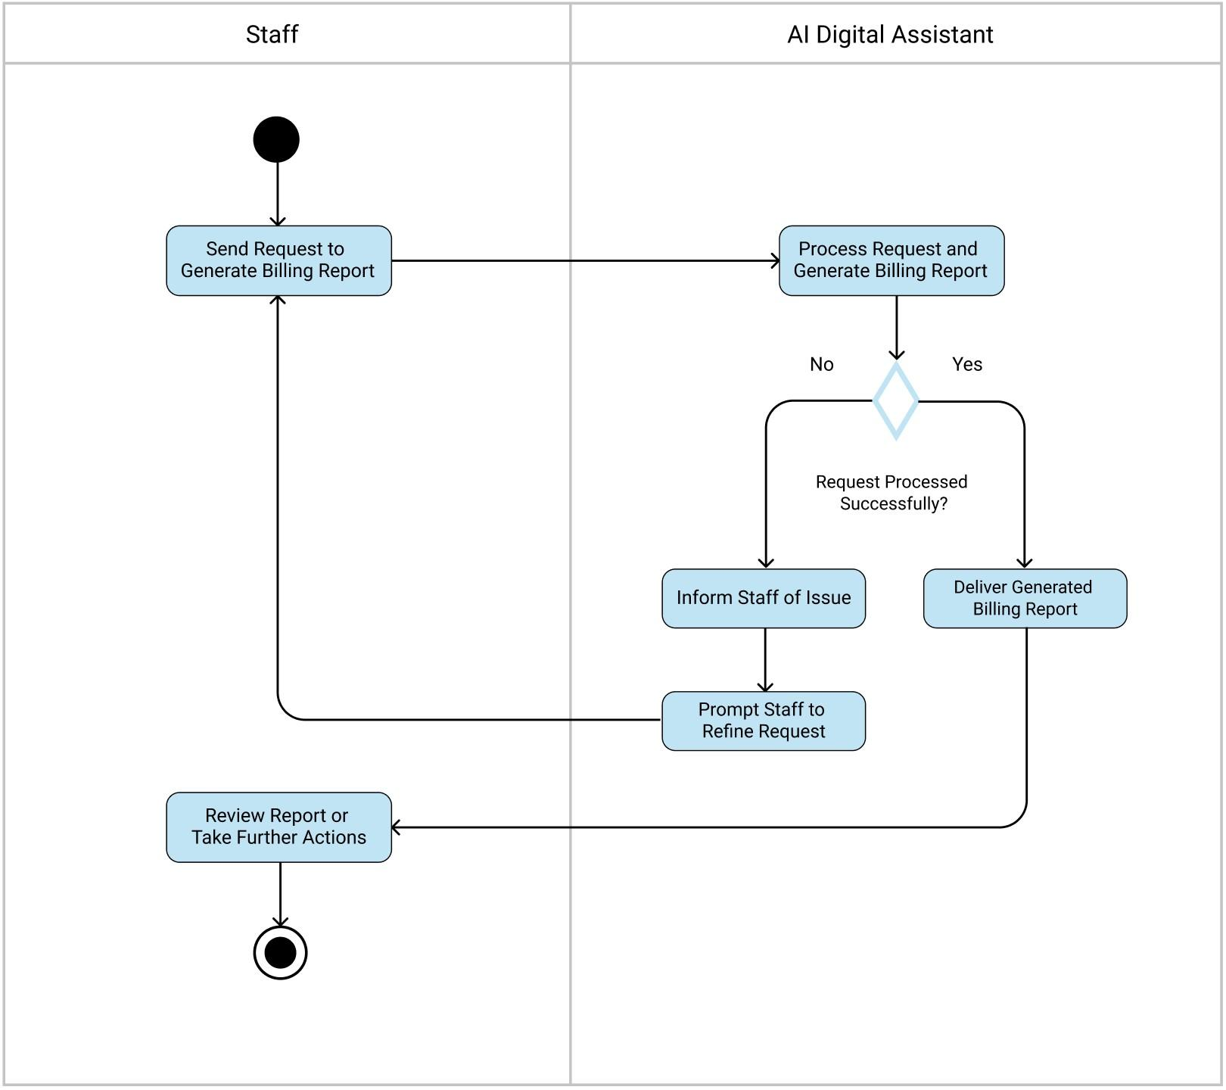

# Fig. 17 Generate Billing Report Activity Diagram with Swimlanes

# V.7 Entity Relationship Diagram

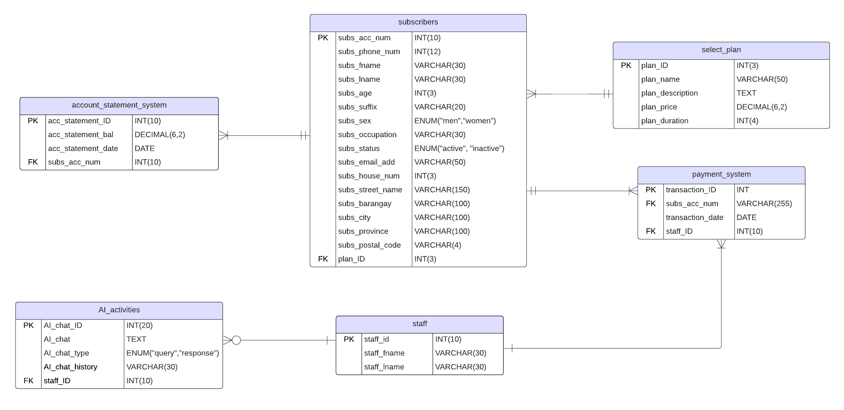

# Fig. 18 Entity Relationship Diagram

# V.8 User Classes and Characteristics

Table XXIX

User Classes and Characteristics

| **Roles** | **Description** |
| --- | --- |
| **Subscriber** | A subscriber is a type of user who avails of D&D I.T's internet services. They can be small business owners or individuals. They use the system to manage their internet plans and payments. |
| **Staff** | Staff responsibilities include managing subscriber accounts, processing billing tasks, handling inquiries, generating reports, updating payment statuses, resolving billing issues, and ensuring the accuracy of subscriber information. |
| **Admin** | Admin have the authority to manage user permissions and configure system settings to ensure smooth operations. |
| **Tech Support** | Tech support staff assist subscribers with technical issues related to their internet service. They access the system to troubleshoot problems and provide solutions to maintain service quality. |

# V.9 Prototype/Wireframe

The prototype is crucial in project development, offering an initial model that highlights key features and functionalities. It acts as a tangible representation of the project's concept, enabling stakeholders to visualize and evaluate its potential. This prototype includes the home, account statement, and payment pages. Additionally, it features the digital assistant’s home page and the query page. The prototype’s color palette is based on the client’s existing website. Moreover, the website is user-friendly and includes enhanced functionalities for easier access by subscribers.

# Homepage

# 

Fig. 19 Prototype for Homepage

The homepage has a sidebar containing options for the home, account statement, and payment pages, along with the company logo and name. A welcome message and the logo are also prominently displayed. There is a section describing the internet plans, providing detailed information as well as their prices. Users can select and confirm their desired internet plans by clicking the respective buttons.

# Account Statement

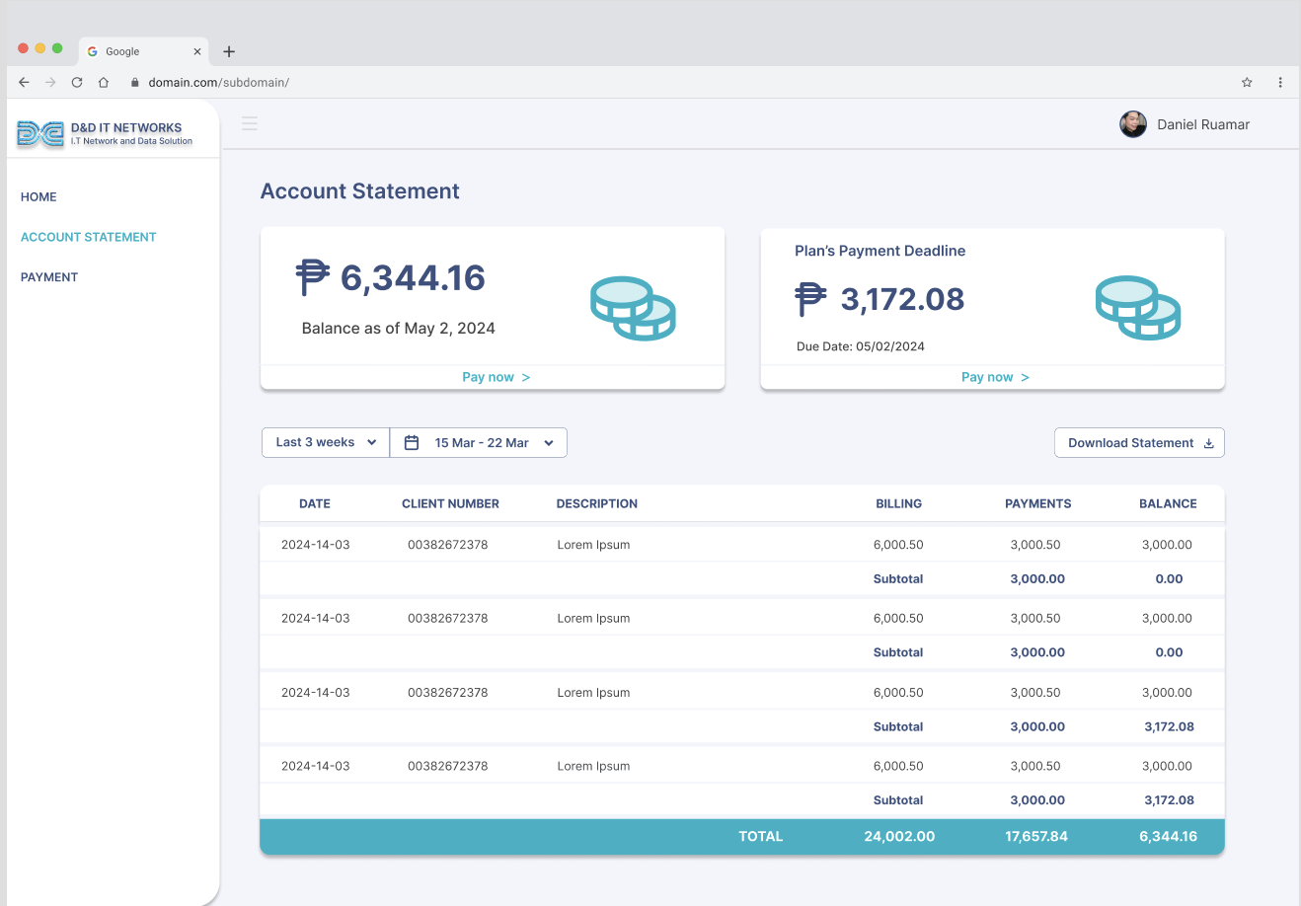

Fig. 20 Prototype for Account Statement Page

The account statement page contains a sidebar. Additionally, it features a section showing subscribers their overall balance and the balance of specific plans. There is a "Pay Now" button that directs users to the payment page. A dropdown menu allows subscribers to select and view statements from specific dates. They also have the option to download their statements by clicking the "Download Statement" button.

# Payment

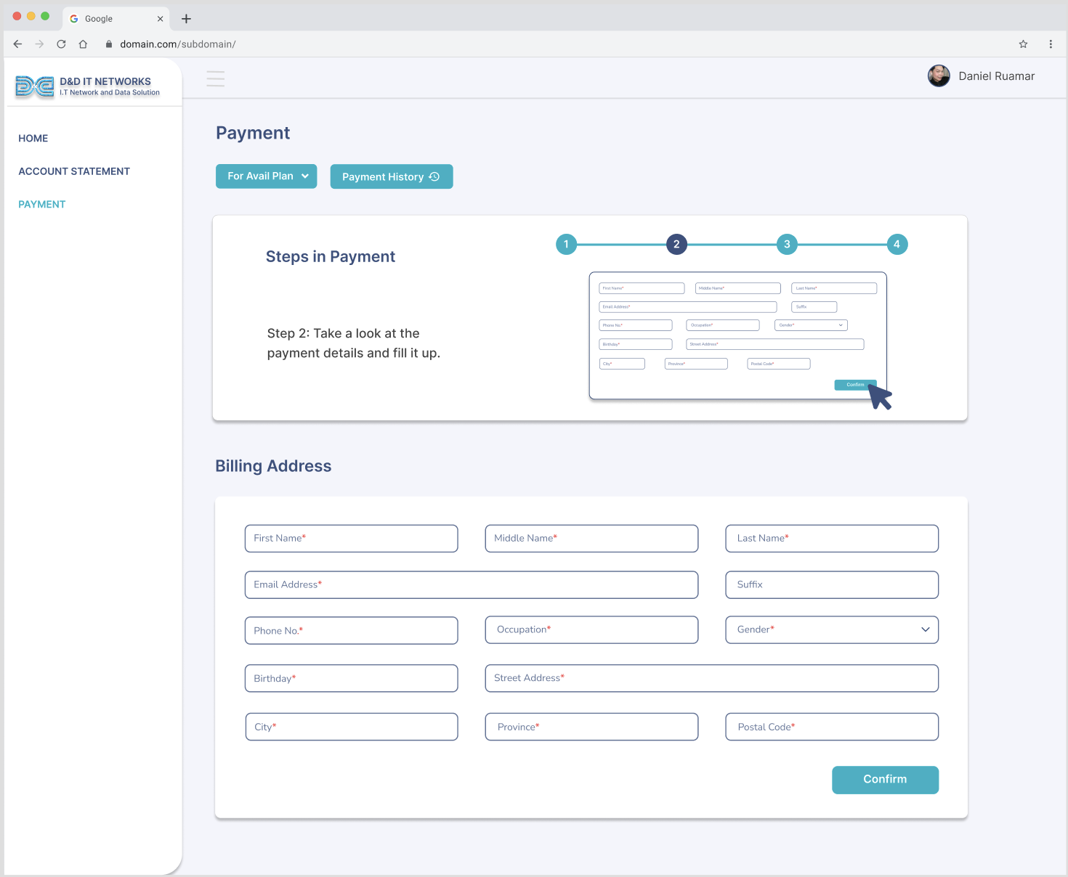

Fig. 21 Prototype for Payment Page

The payment page includes a sidebar with easy navigation options. Subscribers can choose to avail of plans or pay a balance using the dropdown button. There is also a button to view their payment history. The developer has added a step-by-step guide to simplify the payment process. Additionally, the page includes a billing address form where subscribers can enter their personal information. To submit the form, users need to click the "Confirm" button.

# AI Digital Assistant

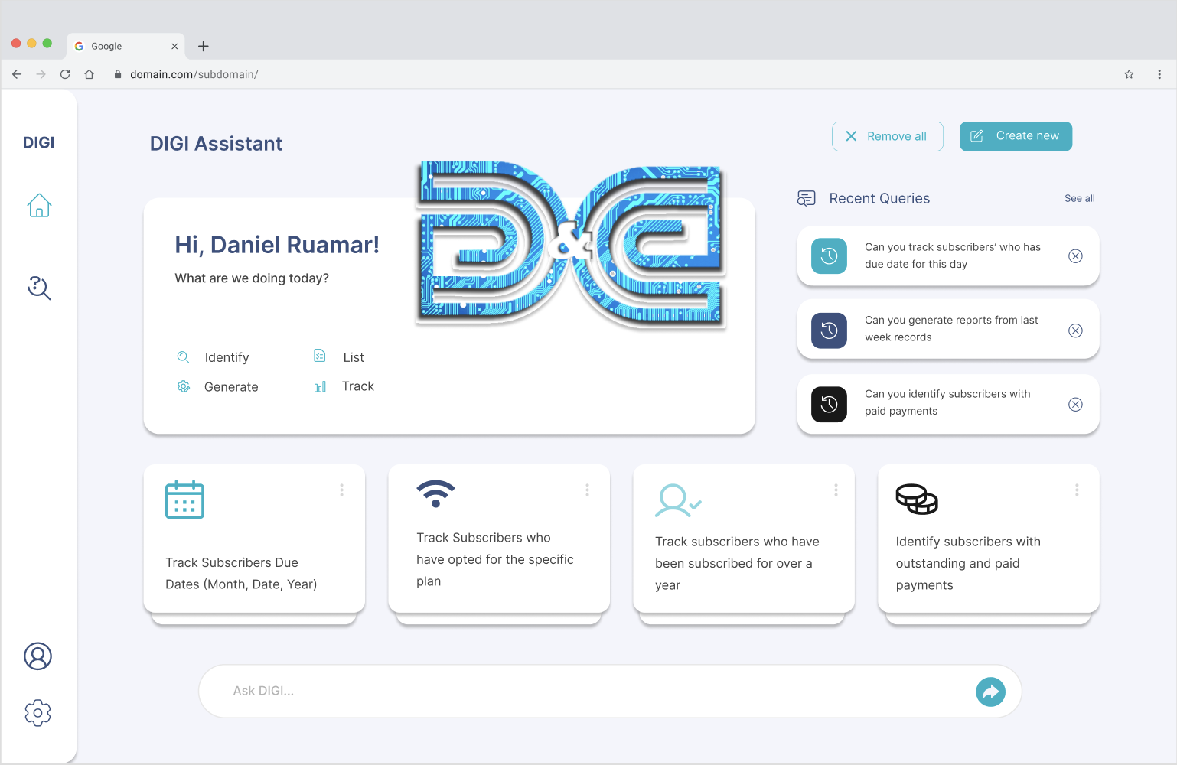

Fig. 22 Prototype for AI Digital Assistant

The AI digital assistant has a sidebar containing the home, history, profile, and settings options. It also includes a welcome page, the company logo, and a list of possible questions users can ask the digital assistant. At the bottom, there are suggested inquiries for the staff. On the right side, recent queries are displayed, and users have the options to remove all, create new queries, see all recent queries, or remove individual ones. Lastly, there is a message bar where staff can ask questions about their records from the system.

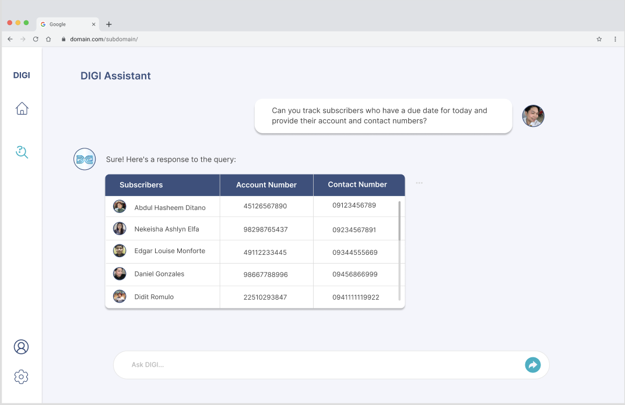

Fig. 23 Prototype for AI Digital Assistant

This page appears after sending a message or inquiry. All answers are generated by the billing system, as the digital assistant is integrated with it. The digital assistant's responses are always presented in table format for better visualization.

# V.10 Release Plan

**Target Group:** D&D I.T Networks and Data Solution  
  
**Goal:** To create an integrated subscriber billing system for easy access to statements and available plans, along with an AI-powered digital assistant for staff inquiries regarding subscribers’ records.

**Needs:** A system for transparent billing statements specifically for subscribers, and an AI digital assistant integrated into the system to address staff inquiries about the records.

**Value:** These systems will benefit DDIT Networks by eliminating manual billing processes, thereby saving time and effort and reducing errors. Additionally, it solves their challenges in tracking billing reports, minimizing confusion and providing generated reports.

**Key Features:** Automated billing system, AI-powered digital assistant, Customer account management, Operational efficiency enhancement.

**Release Plan**

Release 1 MNSTDEV

* Research Paper
* Prototype

Release 2 MSYADD1

* Creation of Diagrams
* Designing the User Interface for the Billing System
* Development of Core Billing Functions (Homepage)
* Development of Login/Signup Features

Release 3 MSCPROJ

* Integration of AI Digital Assistant for handling billing inquiries
* Generation of automated billing reports
* Testing of billing system and AI functionalities
* Finalizing system features based on user feedback
* Full System Deployment
* Post-deployment Support and Maintenance

# References

[1] P. Abraham, “How automated ISP billing system helps in digital evolution of ISPs,” *RackNap Blog - a Guide to Automate Web Hosting and Cloud Business.*<https://www.racknap.com/blog/automated-isp-billing-system-benefits/>

[2] V. Basopo, “Manual vs Automated Billing,” *solidtech.*<https://blog.soliditech.com/blog/manual-v-automated-billing>

[3] “DDIT NETWORKS,” dditnetworksndatasol.com. <https://dditnetworksndatasol.com/>

[4] “THE 17 GOALS | Sustainable Development.” <https://sdgs.un.org/goals>

[5] P. B. De Oliveira, “Improving Customer Experience - Predictive Model of Billing Service Requests.”<https://repositorio-aberto.up.pt/bitstream/10216/121964/2/347487.pdf>

[6] M. Reppa, “TELECOMMUNICATIONS CONVERGENT BILLING SYSTEM EVALUATION AND METHODS TO OPTIMIZE PERFORMANCE,” [*www.academia.edu*](https://www.academia.edu), <https://www.academia.edu/35126342/TELECOMMUNICATIONS_CONVERGENT_BILLING_SYSTEM_EVALUATION_AND_METHODS_TO_OPTIMIZE_PERFORMANCE>

[7] R. B. Bidin, “Improving Customer Billing Telephony Using User Experience Approach.”<http://psasir.upm.edu.my/id/eprint/68959/1/FSKTM%202018%2039%20-%20IR.pdf>

[8] R. E. Balmer, S. L. Levin, and S. Schmidt, “Artificial Intelligence Applications in Telecommunications and other network industries,” Telecommunications Policy, vol. 44, no. 6, p. 101977, Jul. 2020: <https://www.sciencedirect.com/science/article/abs/pii/S0308596120300690>

[9] H. M. F. M. da S. Veríssimo, “How emerging technologies impact companies´ business models : the case of AI in the telecom industry,” repositorio.ucp.pt, Feb. 03, 2021. <https://repositorio.ucp.pt/handle/10400.14/34769>

[10] M. Kyto, “Copilot for Microsoft 365: A Comprehensive End-user Training Plan for Organizations,” 2024. Available: <https://www.theseus.fi/bitstream/handle/10024/852578/Kyto_Miska.pdf?sequence=2&isAllowed=y>

[11] Freed, "Conversational AI: A Complete Guide," 2020. <https://books.google.com.ph/books?hl=en&lr=&id=XN9BEAAAQBAJ&oi=fnd&pg=PA1&dq=AI+assistant+for+billing+software&ots=1-yNn0Tg5J&sig=4xlXrqFi7-Yq4H9TMV4soDs-y6o&redir_esc=y#v=onepage&q&f=false>

[12] R. Yan, “‘Chitty-Chitty-Chat Bot’: Deep Learning for Conversational AI.”<https://www.ijcai.org/proceedings/2018/0778.pdf>

[13] “What is OpenAI?,” *Moveworks*.<https://www.moveworks.com/us/en/resources/ai-terms-glossary/openai>

[14] “Spring boot,” *Spring Boot*.<https://spring.io/projects/spring-boot#overview>

# Appendices

## Appendix A: Project Vision

The project aims to develop an advanced billing system integrated with an AI-powered digital assistant tailored for D&D I.T Network and Data Solution. This initiative is focused on enhancing billing accuracy, optimizing operational processes, and boosting customer satisfaction by automating billing procedures, improving payment tracking capabilities, and providing subscribers with intuitive access to their statements and service plans. Key components include implementing an automated billing system to simplify statement management and plan exploration, alongside deploying an AI assistant to handle staff inquiries and generate detailed billing reports. These innovations aim not only to enhance internal efficiency but also to fortify transparency and responsiveness in customer interactions.  
  
 Structured across strategic milestones, the project begins with client interviews and problem identification, followed by brainstorming and proposal drafting. It progresses through prototype development, data modeling, and system design phases, culminating in the integration of advanced functionalities. This phased approach ensures a robust solution that aligns with D&D I.T Network and Data Solution's objectives of delivering dependable internet services and strengthening its market leadership in the Philippines.

## Appendix B: Schedule/Release Plan

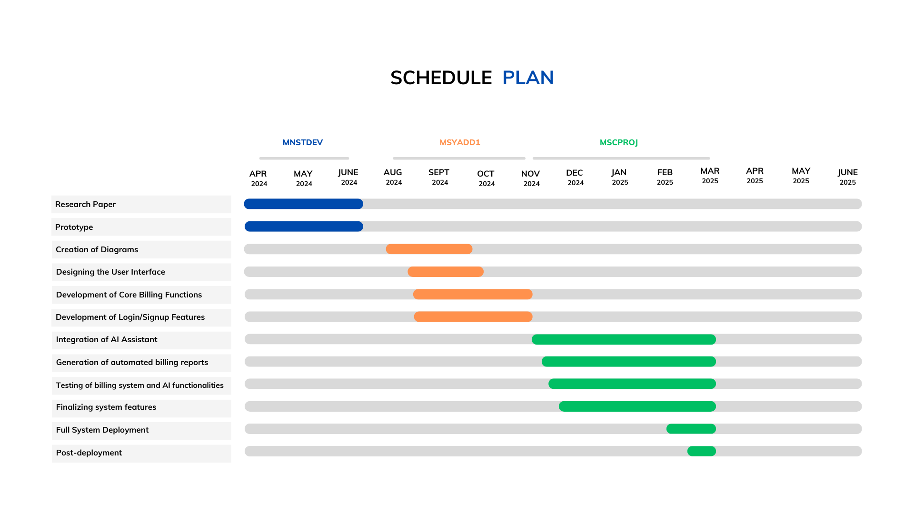

Fig. 24 Schedule/Release Plan

The project schedule outlines a comprehensive timeline divided into three phases: MNSTDEV, MSYADD1, and MSCPROJ, spanning from April 2024 to June 2025. This structured approach ensures a systematic progression through the project, facilitating effective management and timely delivery of each phase.

## Appendix C: Product Roadmap

Table XXX

Roadmap

Billing System with an AI-Powered Digital Assistant for Enhanced Client Efficiency: A Solution for D&D I.T Network and Data

| **MNTSDEV** | **MSYADD1** | **MCSPROJ** |
| --- | --- | --- |
| **Midterms**   * Looking for the client * Interview to collect ideas about the company * Identifying the problem faced by the company and its subscribers * Brainstorming on what project we are going to implement * Draft proposal   **Finals**   * Final project proposal * Wireframes/Prototype | **Milestone 1**   * Implementation of panelists’ advice     **Milestone 2**   * Creation of Diagrams     **Milestone 3**   * Development of Core Billing Functions | **Milestone 4**   * Improvement of the initial prototype     **Milestone 5**   * 60% of systems implemented complete     **Milestone 6**   * 90% of systems completed and hosted     **Milestone 7**   * Project 100% working |

## Appendix E: Teams Meetings

Date: April 17, 2024 Time: 1:00 PM - 2:00 PM

**Attendees:**

* Abdul Hasheem Ditano
* Nekeisha Ashlyn Elfa
* Edgar Louise Monforte
* Jean Christian Larr Murillo

**Objective/Purpose:**

The meeting was held to meet with our client, address their concerns, brainstorm solutions to their stated problem, and finalize the selection of a prospect adviser.

**Agenda Review:**

The agenda items included:

1. Meet our client and ask questions.
   * Discussed the client's problems/concerns.
   * Identified key areas where the client seeks assistance.
2. Brainstorm solutions to the problem stated by the business owner.
   * Analyzed the problem statement provided by the client.
   * Brainstormed potential solutions and strategies to address the identified issues.
3. Decide on a prospect adviser and create a letter.
   * Reviewed profiles of potential advisers based on expertise and experience.

**Adjournment:**

The meeting adjourned at 2:00 PM

Date: April 24, 2024

Time: 7:30 PM - 9:45 PM

**Attendees:**

* Abdul Hasheem Ditano
* Nekeisha Ashlyn Elfa
* Jean Christian Larr Murillo

**Absent:**

Edgar Louise Monforte

**Objective/Purpose:**

The meeting was convened to create a lean canvas and engage in a brainstorming session to address our client's concerns and generate potential solutions for their stated problem.

**Agenda Review:**

The agenda items included:

1. Create Lean Canvas.

* Discussed the elements of the lean canvas model.
* Identified key components relevant to our client's business and problem.
* Assigned responsibilities for drafting the lean canvas.

**Adjournment:**

The meeting adjourned at 9:45 PM

Date: May 15, 2024

Time: 3:30 PM – 4:30 PM

**Attendees:**

* Abdul Hasheem Ditano
* Nekeisha Ashlyn Elfa
* Jean Christian Larr Murillo
* Edgar Louise Monforte

**Objective/Purpose:**

The meeting was convened to meet with our adviser Ms. Jo Anne to discuss our project proposal, seek suggestions on improving the project, and consult on the Lean Canvas.

**Agenda Review:**

The agenda items included:

1. Project Proposal Review:

* Presentation of the current project proposal.
* Discussion on the objectives, scope, and expected outcomes.
* Identification of potential areas for improvement.

1. Suggestions for Improvement:

* Adviser’s feedback on the project proposal.
* Specific suggestions on enhancing the proposal’s clarity, feasibility, and impact.

1. Lean Canvas Consultation:

* Explanation of the Lean Canvas model.
* Guidance on how to effectively use the Lean Canvas for the project.

**Adjournment:**

The meeting adjourned at 4:30 PM

Date: May 29, 2024

Time: 2:00 PM – 3:00 PM

**Attendees:**

* Abdul Hasheem Ditano
* Nekeisha Ashlyn Elfa
* Jean Christian Larr Murillo

**Absent:**

Edgar Louise Monforte

**Objective/Purpose:**

The meeting was convened to meet with our adviser, Ms. Jo Anne, for a consultation on Chapter 1.

**Agenda Review:**

The agenda items included:

1. Introduction and Purpose

* Brief overview of the meeting's objectives.

1. Discussion on Chapter 1

* Detailed review of the current draft.
* Identification of key areas needing improvement.
* Advisor's feedback and suggestions for revision.

**Adjournment:**

The meeting adjourned at 2:30 PM

